New York Bight  
Indicator Report 2022

**MOU #AM10560 NYS DEC & SUNY Stony Brook**

**___**

Report contributors: Laura K. Gruenburg, Janet A. Nye, Lesley Thorne, Tyler Menz, Baoshan Chen, Eleanor Heywood, Chelsi Napoli, Joe Warren, Charles Flagg, Jack McSweeney

Contact Principal Investigator, Janet A. Nye with questions or comments janet.nye@stonybrook.edu

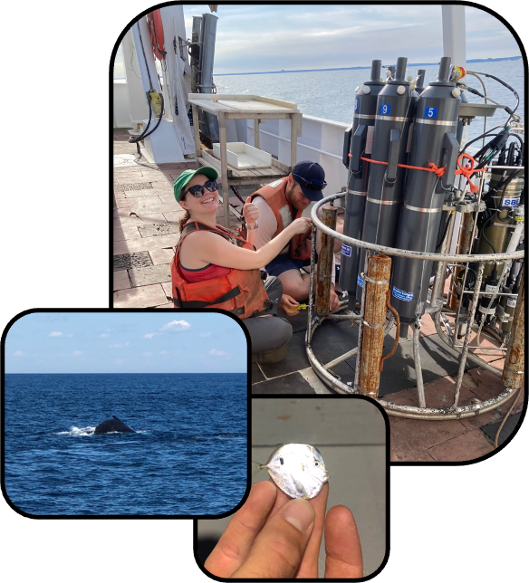

# 

**Part I. Indicator Analysis**4

1. Indicators at a Glance 4

2. Executive Summary 8

3. Report Structure 8

4. Physical and Chemical Indicators 9

Summary 9

Seasonal Mean Sea Surface Temperature 10

Marine Heatwave Days 11

Bottom Temperature Anomaly 13

Cold Pool Volume in NYB 14

Bottom Dissolved Oxygen 15

Ocean Acidification Risk 16

Mean Wind Speed 17

Stratification Anomaly 18

Hudson River Flow 19

Salinity 20

Global Carbon Dioxide 21

Location of Surface 20°C Isotherm 21

Lobster Thermal Habitat 26

5. Marine Community 26

Summary 26

Monthly Mean Surface Chlorophyll 27

Calanus finmarchicus abundance 28

Copepod Size Index 29

Commercially Important Invertebrates 30

Forage Species Biomass 34

Aggregate Feeding Groups 35

Total Trawl Biomass 36

Ratio of northern to southern species, finfish, and macroinvertebrates 37

Ratio of Benthic to Pelagic Species 40

Fish Species Richness 41

Average Trophic Level of the Fish Community 42

Temperature preference of the fish community 43

6. Human Populations 43

Summary 43

Commercial Fisheries Landings 44

Commercial Landings Value 45

Recreational Harvest 46

Recreational Effort 47

Vessel Density 48

Human Population of Long Island 50

Sea Level Risk for Long Island Communities 50

**Part II. Ongoing Indicator Development**52

Whale Body Condition 52

Odontocete Strandings 54

Hudson River Flow Ongoing Development 56

**Data Sources**62

**Acknowledgements**63

**References** 63

# Part I. Indicator Analysis

## Indicators at a Glance

In the tables below indicators marked with an asterisk (*) have been calculated differently from the previous report. Those indicators marked with a caret (^) are still under ongoing improvement or development. The long term trend column indicates an increase or decrease in any significant linear trend over the whole time series of that indicator. The short term trend shows whether the indicator was increasing or decreasing over the previous three years only.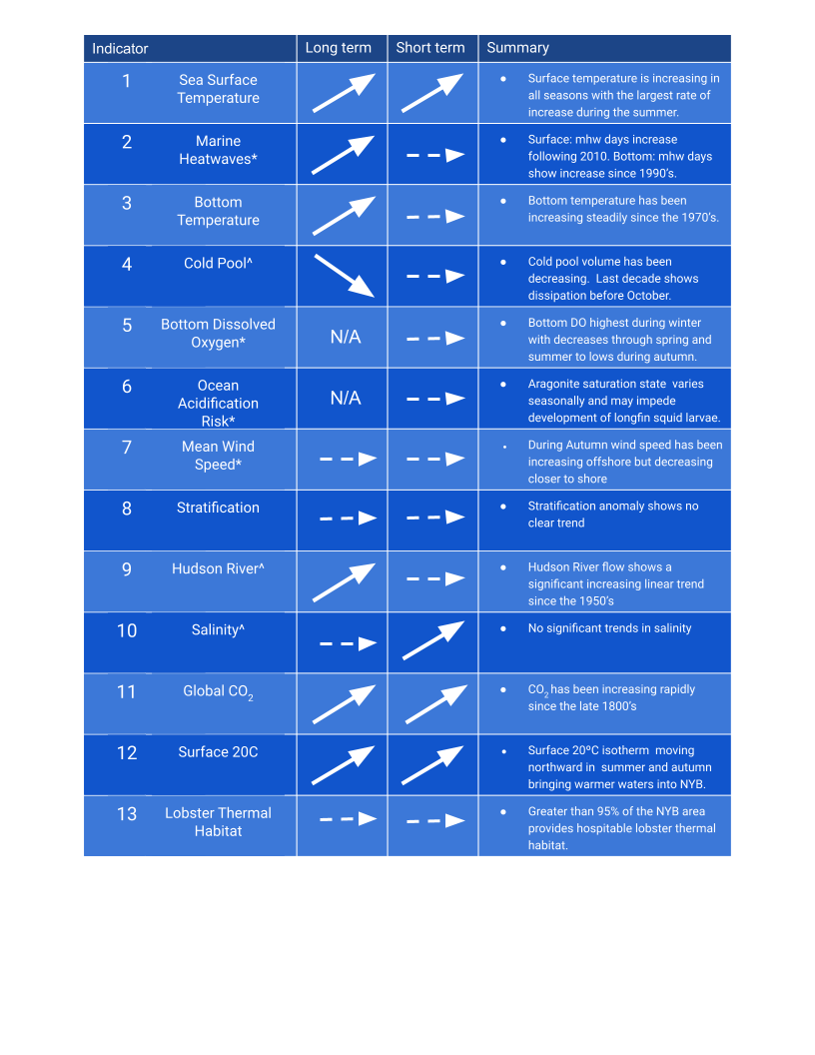

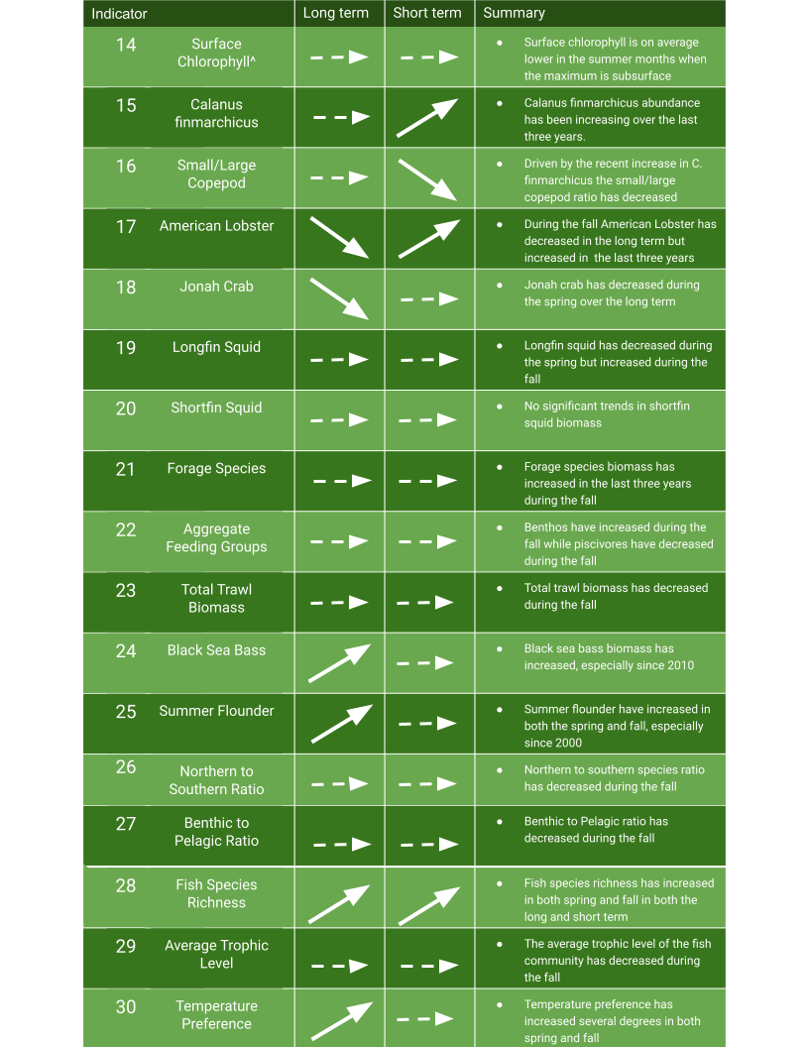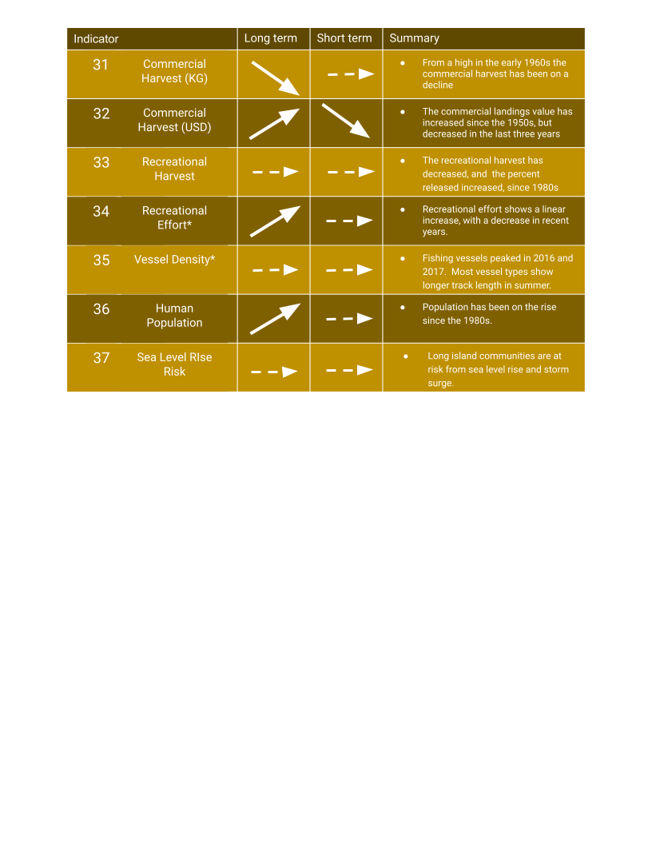

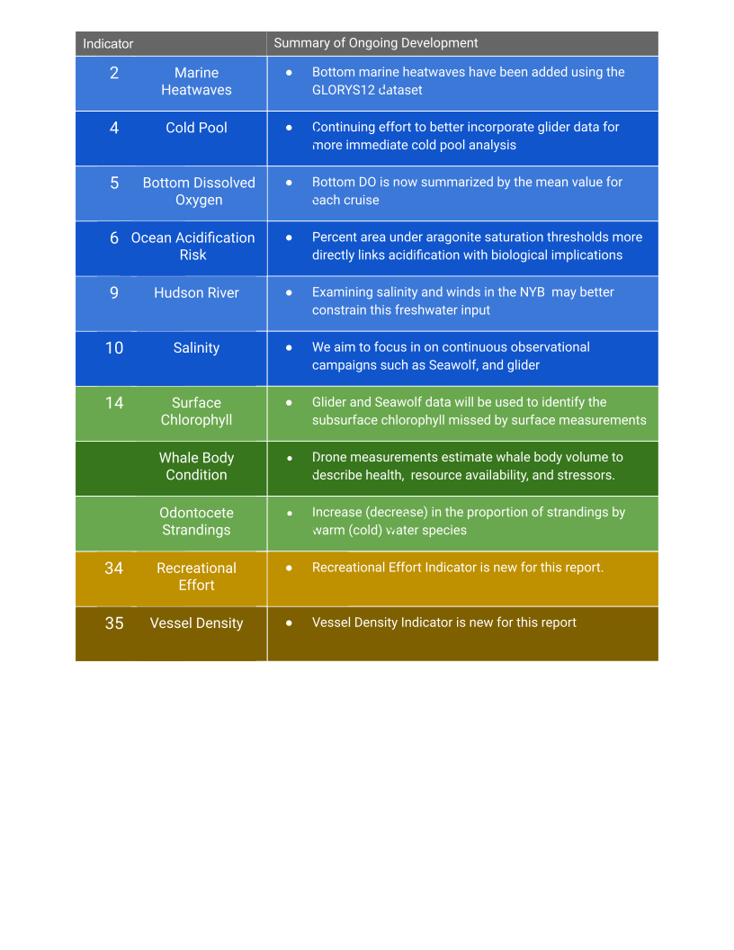

## Executive Summary

Warming continues throughout the New York Bight (NYB) at the surface, at depth, across all seasons, and in terms of marine heatwave days in both surface and bottom water. The cold pool, a biologically important seasonal feature within the NYB, has been dissipating prior to October consistently over the last decade, possibly influenced by warming autumn temperatures. Increases in temperature are not uniformly harmful, some species such as summer flounder and black sea bass, a warm water species, have been increasing and may benefit from this warming. Fish species richness is increasing, as is the temperature preference of the fish community, indicating more warm water species are finding an agreeable environment within the NYB.

The increase in temperature could reduce the ability of the ocean water to hold certain gasses. Our observations indicate that this has not yet become a problem as bottom dissolved oxygen levels do not approach hypoxic levels. Ocean acidification occurs as atmospheric CO2 rises, dissolves into ocean water, and decreases pH. Ocean acidification may be of concern to certain species within the NYB and in this report we used literature values of sensitivity to ocean acidification to assess risk to this stressor. Specifically, longfin squid larvae may experience difficulty with growth due to ocean acidification. Longfin squid are one of the most economically important species for the commercial fishery within the NYB and despite decreases in the spring, their population has been increasing in the fall with the largest biomass since the 1960’s reported in 2021.

Recreational and commercial fisheries were affected by the COVID19 pandemic with decreases in harvest in recent years. Efforts by the state to provide relief have come as increases in funding for temporary assistance to commercial fishers and for-hire fishing vessel operators.

## Report Structure

The 2022 indicator report contains new and developing indicators across all three indicator groups. Data sources for all indicators can be found in the Data Sources table on page #. Within physical and chemical indicators marine heatwaves now include bottom marine heatwaves calculated using daily data from the GLORYS12 reanalysis dataset. This will help us to understand how large changes in temperature may affect benthic organisms. The bottom dissolved oxygen indicator includes an additional three years of data, encompassing all Seawolf cruises completed to date. The mean wind stress indicator has been changed to mean wind speed to be more easily understood at a glance, and two additional buoys have been added to show how wind speed is changing over time at different locations ranging from onshore to offshore. Ocean acidification risk is quantified using the area under certain aragonite saturation state thresholds that correspond to limits for the successful growth of important living marine resources in NY. Aragonite is the form of calcium carbonate that these organisms use for hard structures. After doing a full literature search we used the threshold for pteropods, marine snails that play an outsized role in the marine food web, and longfin squid which make up an economically important commercial fishery in the NYB. Within the biological indicators group we continue to develop indicators for whale body condition and odontocete strandings which will provide unique insights into the health of marine mammal populations. More details about this ongoing work can be found in Part II. The human populations indicators have been added to with our new Vessel Density and Recreational Effort indicators.

Except where expressly stated all figures show yearly mean values in grey dots connected by grey lines. Discontinuities in the line represent a data gap either an absence of data for that year or data only outside of the bounds of the NYB. A black triangle indicates data that is new for this year’s report. A dot dash black line shows the nonlinear GAM with periods of significant increase shown in the solid blue line and periods of significant decrease in the solid red line. If a statistically significant (greater than 95% confidence interval) linear trend is present it is shown by a solid black line. The box below summarizes these symbols and appears again in each indicator subsection.

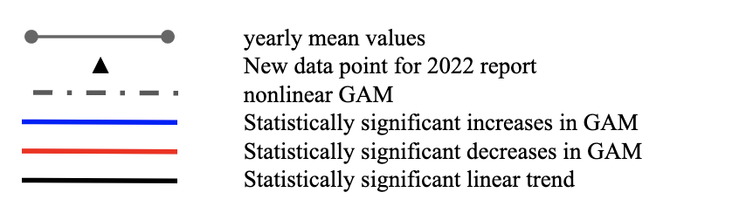

## Physical and Chemical Indicators

### 

### Summary

Waters within the NYB continue to warm with surface temperatures increasing across all four seasons. During the summer, where increases were the fastest, temperature has plateaued over the last five years. Bottom temperatures also continue to increase. Temperature increase can also be understood by looking at marine heatwaves. Within the NYB these heatwaves at the surface have increased, bringing us into a new regime where there have been at least 50 days per year of heatwaves annually since 2010. Marine heatwaves at the seafloor have also been increasing although the regime shift present in the surface is not apparent at depth. These warming temperatures have likely contributed to the earlier absence of the cold pool in autumn. Dissolved oxygen at the seafloor is highest during the winter and lowest during the summer, but is consistently above levels that would indicate hypoxia. We use aragonite saturation state as an indicator of ocean acidification. Low aragonite saturation state can cause planktonic and benthic shell-forming marine organisms to respond with reduced survival, calcification rates, growth, and reproduction, as well as impaired development, and/or changes in energy allocation. When aragonite saturation state is less than one, shells begin to dissolve, but some organisms exhibit negative responses in calcification and other processes when aragonite saturation state is as low as three. Although we do not see aragonite saturation levels low enough to cause serious problems for most marine calcifiers, including pteropods, more sensitive organisms, such as the economically important longfin squid, may already be feeling the effects of ocean acidification. Summer aragonite saturation in up to 40% of NYB waters may be low enough to impede the growth of longfin squid larvae.



### Seasonal Mean Sea Surface Temperature

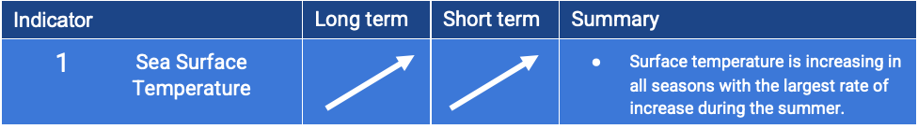

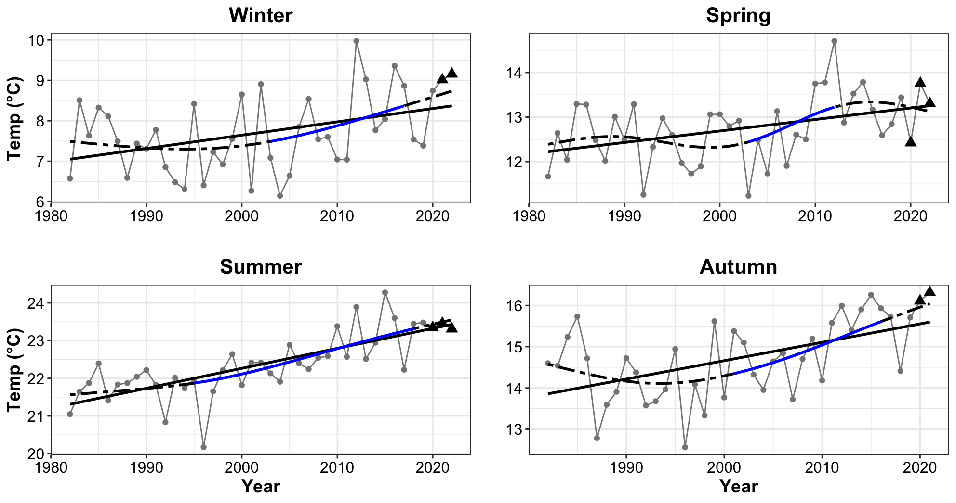

Figure 1. Seasonal mean sea surface temperature is increasing across all seasons with the largest increases in the summer and autumn months.

### Marine Heatwave Days

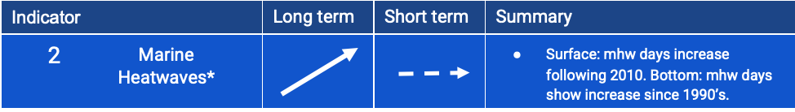

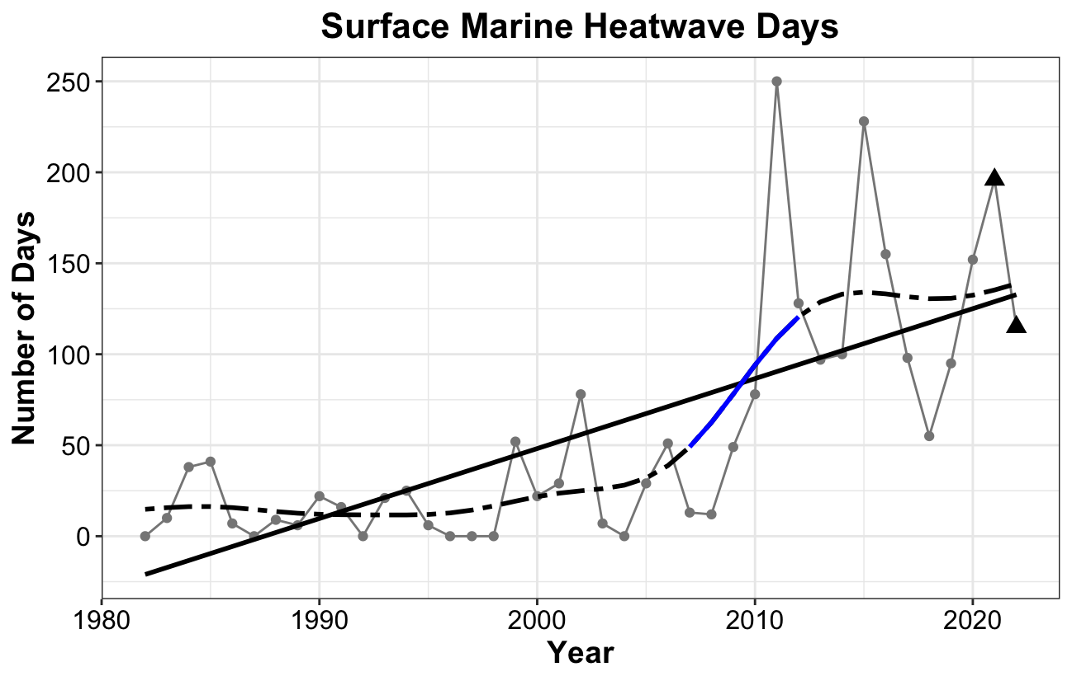

Figure 2. Surface marine heatwave days per year. A regime shift occurred after 2010 with marine heatwave dates increasing to consistently greater than 50 days per year.

### 

Figure 3. Bottom marine heatwave days. Bottom marine heatwaves have been increasing over the last 25 years.

### Bottom Temperature Anomaly

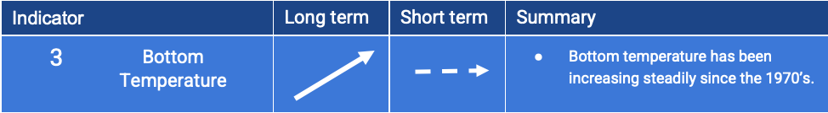

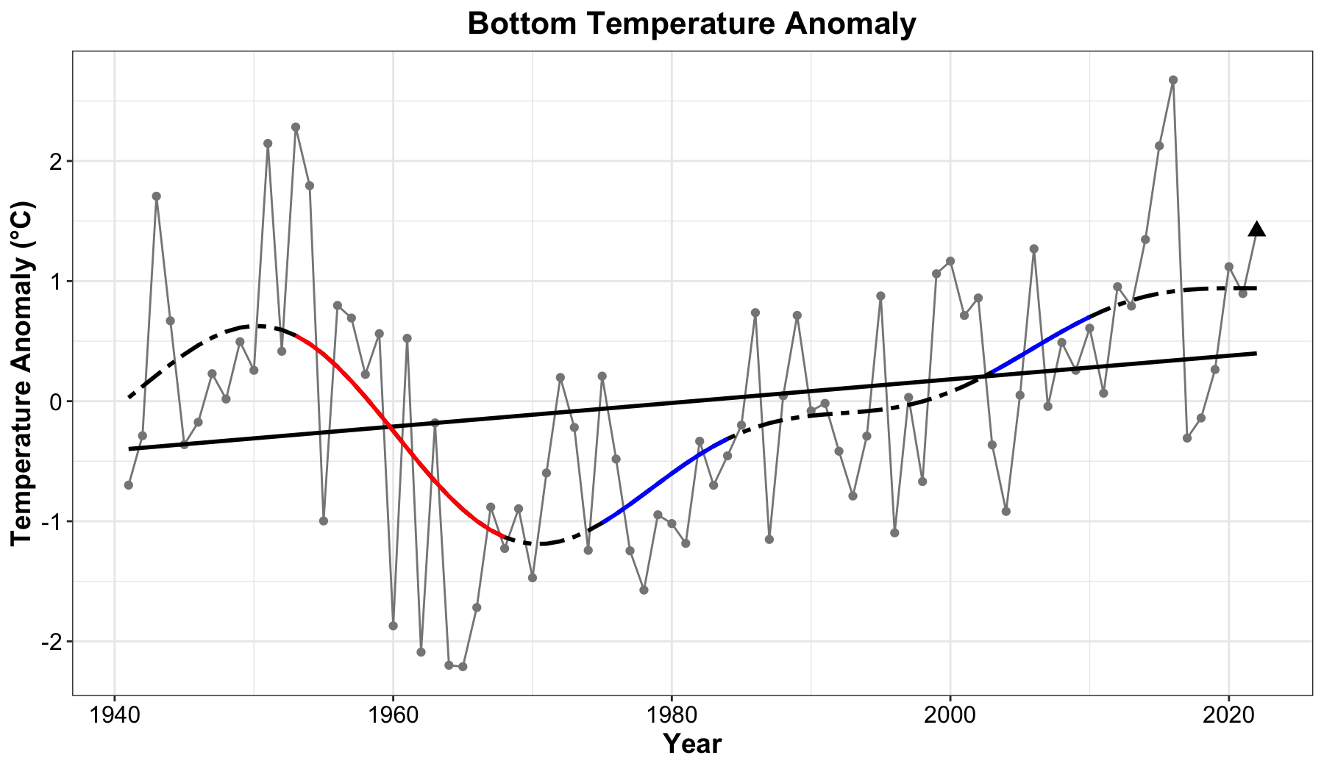

Figure 4. Bottom temperature anomaly has been steadily increasing since the 1970’s.

### 

### 

### Cold Pool Volume in NYB

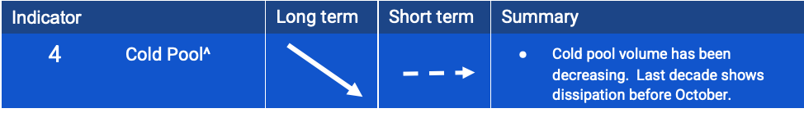

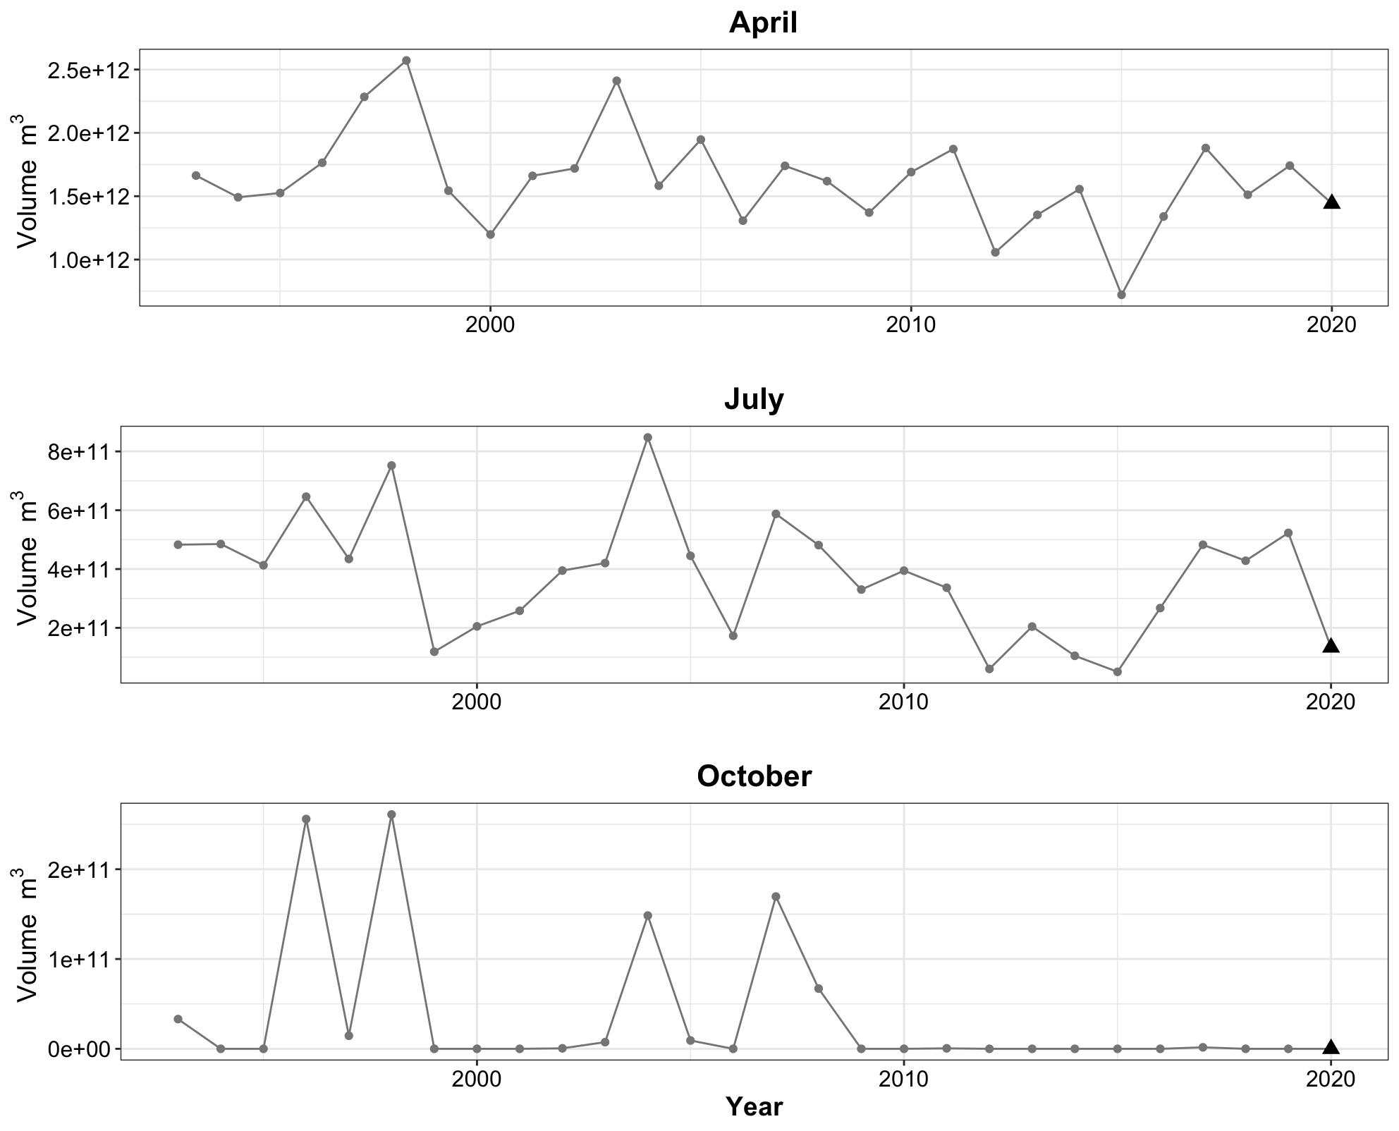

Figure 5. Cold pool volume within the NYB during formation (*top*: April), through the summer (*middle*: July) and dissolution (*bottom*: October). Throughout the last decade the cold pool has dissolved prior to October.

### Bottom Dissolved Oxygen

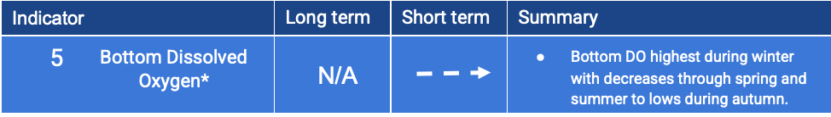

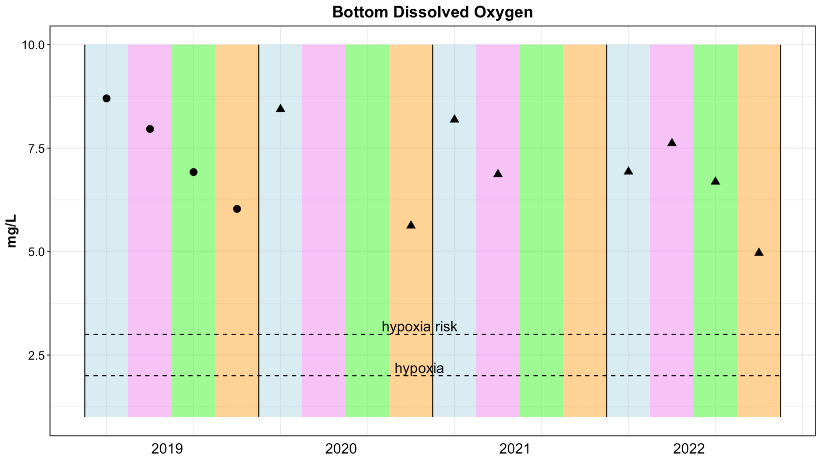

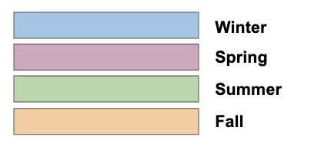

Figure 6. Bottom dissolved oxygen. Each datapoint shows the mean bottom dissolved oxygen value for one seasonal cruise. All four seasons are sampled in 2019 and 2022. During 2020 only winter and fall were sampled and during 2021 only winter and spring were sampled.

### 

### 

### 

### 

### 

### Ocean Acidification Risk

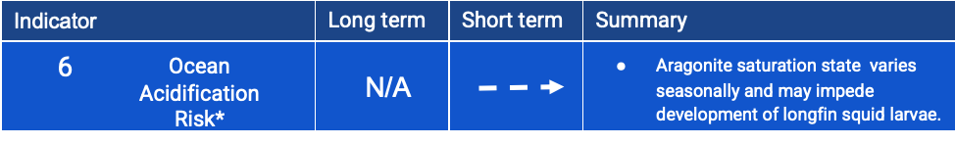

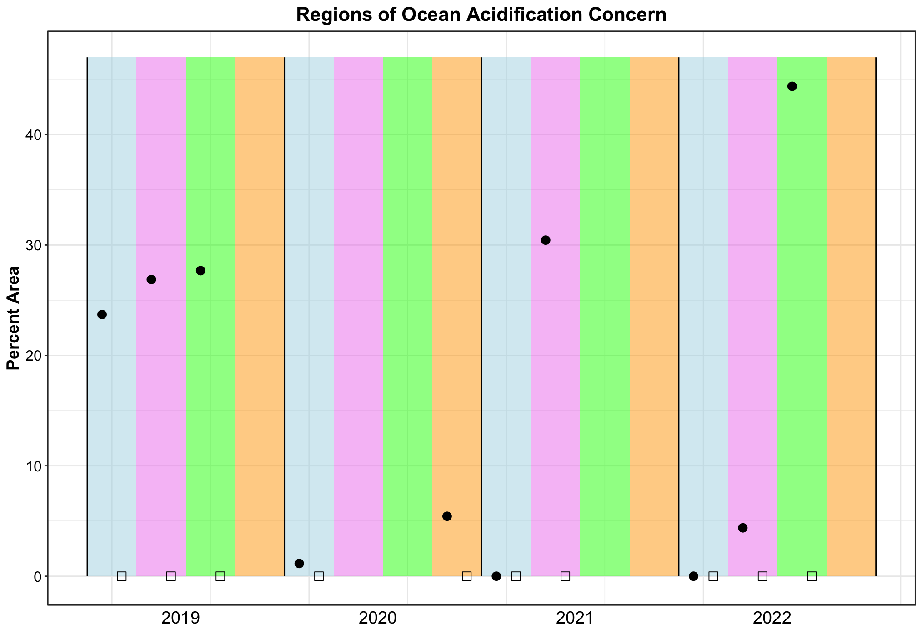

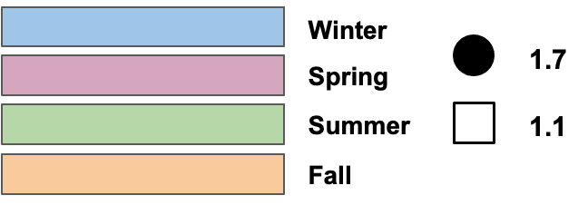

Figure 7. Regions of Ocean Acidification Concern are shown as portions of transect six that are below various aragonite saturation state thresholds. Aragonite saturation state lower than 1.7 (solid circle) may be detrimental to the growth of longfin squid. Aragonite saturation state lower than 1.1 (square) may inhibit growth of pteropods (marine snails). In winter and spring of 2022 transect six was not completed, data from transect seven is presented during those seasons.

### Mean Wind Speed

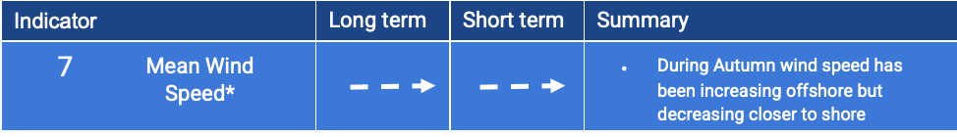

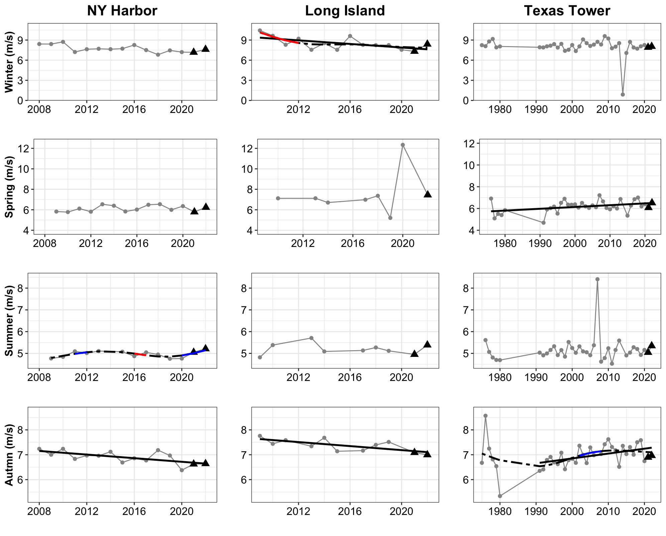

Figure 8. Seasonal mean wind speed is shown at 3 NOAA buoys within the NYB. One buoy is located in NY Harbor, one slightly offshore of Islip on Long Island, and one (Texas Tower) farthest offshore. In the autumn wind speed is decreasing at the first two buoy locations while it is increasing at Texas Tower.

### Stratification Anomaly

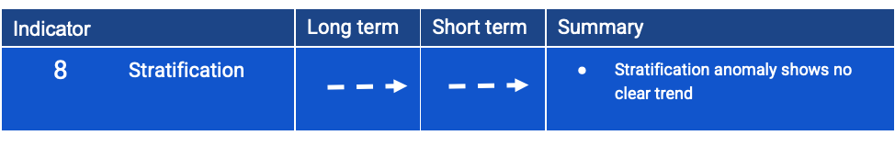

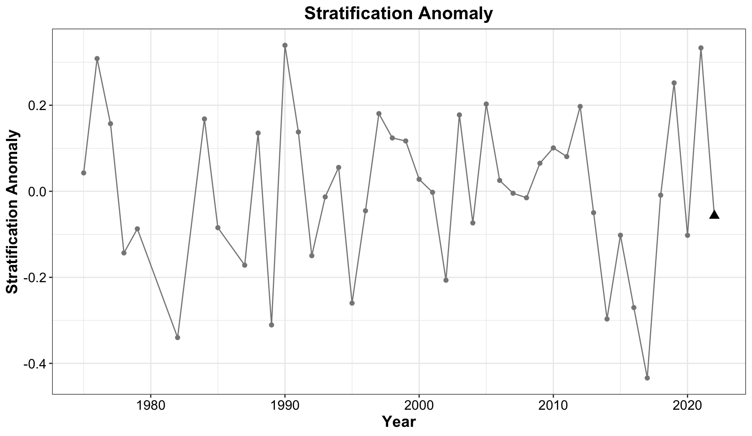

Figure 9. Stratification anomaly, with negative values indicating decreased stratification and positive increased stratification. The timeseries of stratification anomaly does not show any statistically significant linear or nonlinear trends.

### Hudson River Flow

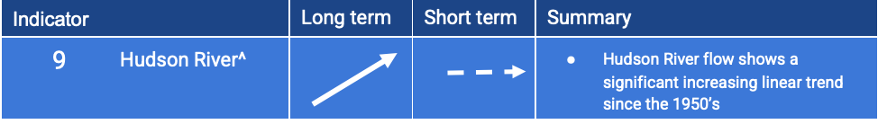

### 

Figure 10. Yearly mean Hudson River flowrate in m3/s at the Green Island USGS river gauge.

### 

### 

### 

### 

### 

### 

### Salinity

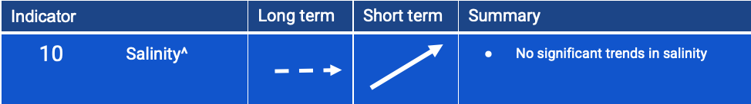

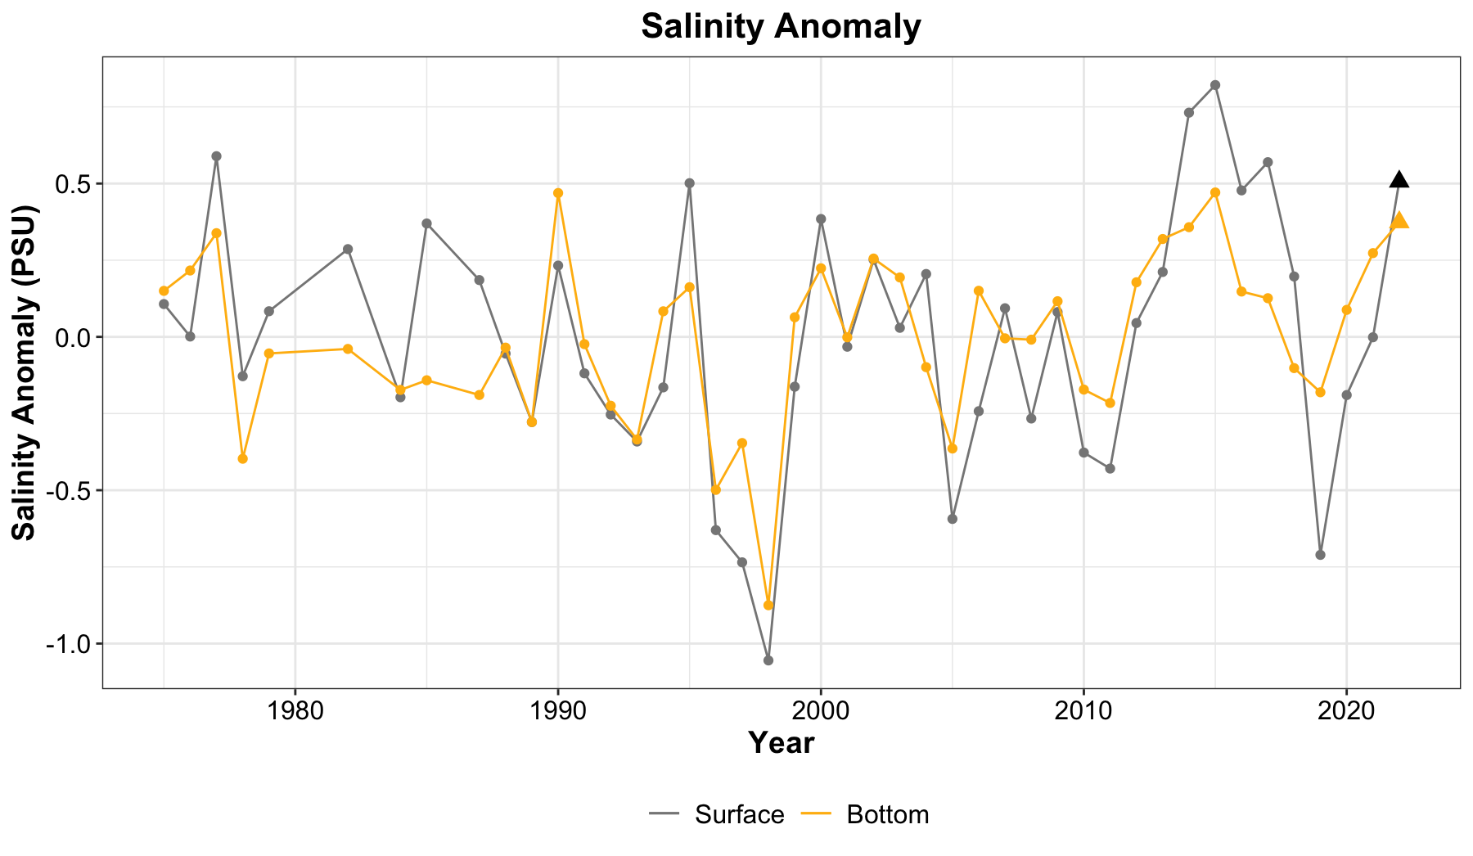

Figure 11. Salinity anomaly from CTD combined with Seawolf data shows no statistically significant linear or nonlinear trend over the whole time series. In the last three years salinity anomaly has increased both at the surface and at depth.

### Global Carbon Dioxide

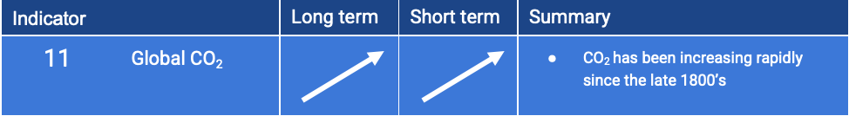

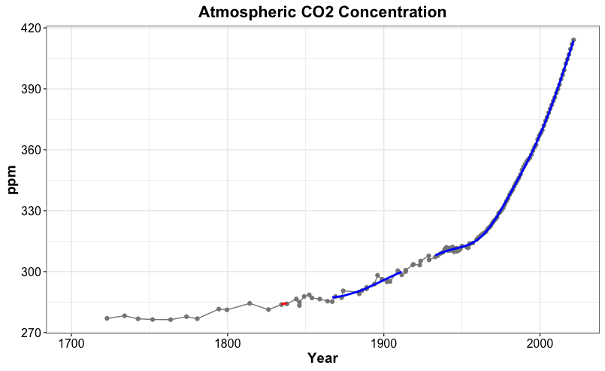

Figure12. Global mean atmospheric CO2. Atmospheric CO2 continues to rise.

### 

### 

### 

### Location of Surface 20°C Isotherm

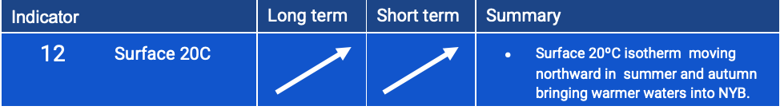

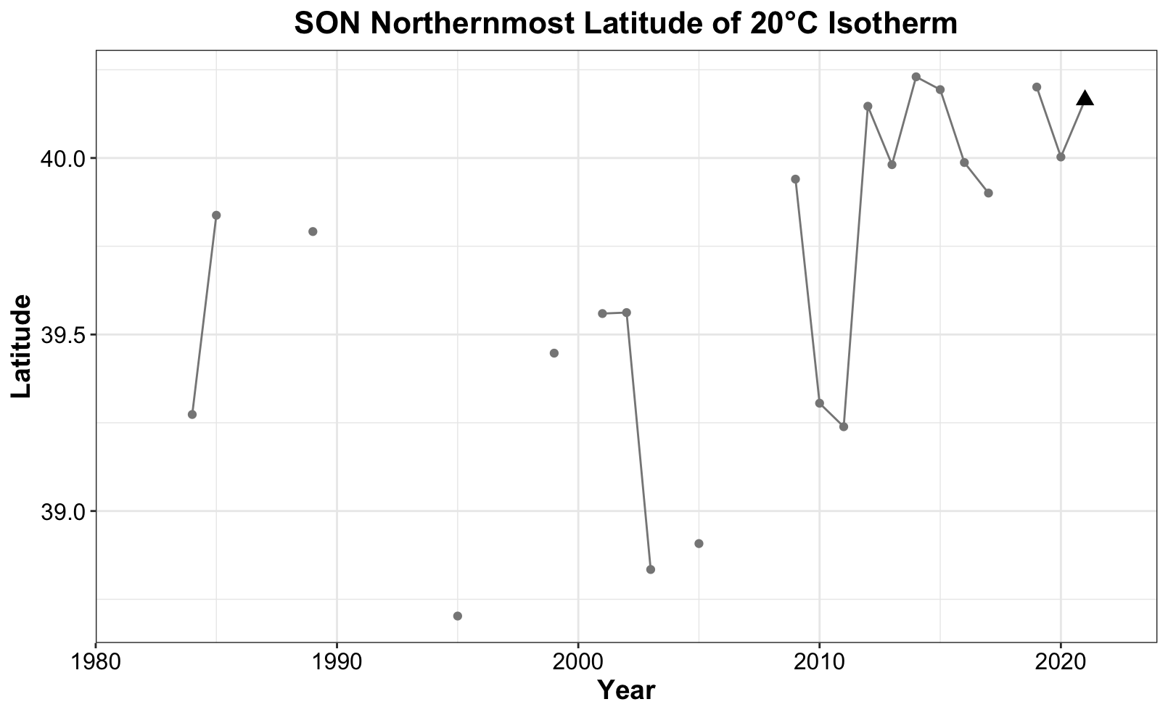

Figure 13. Northernmost latitude of the 20°C surface isotherm during autumn (September, October, November). Missing data points indicate years where the 20°C isotherm was south of the NYB. Figure 16 shows this northward progression in map view.

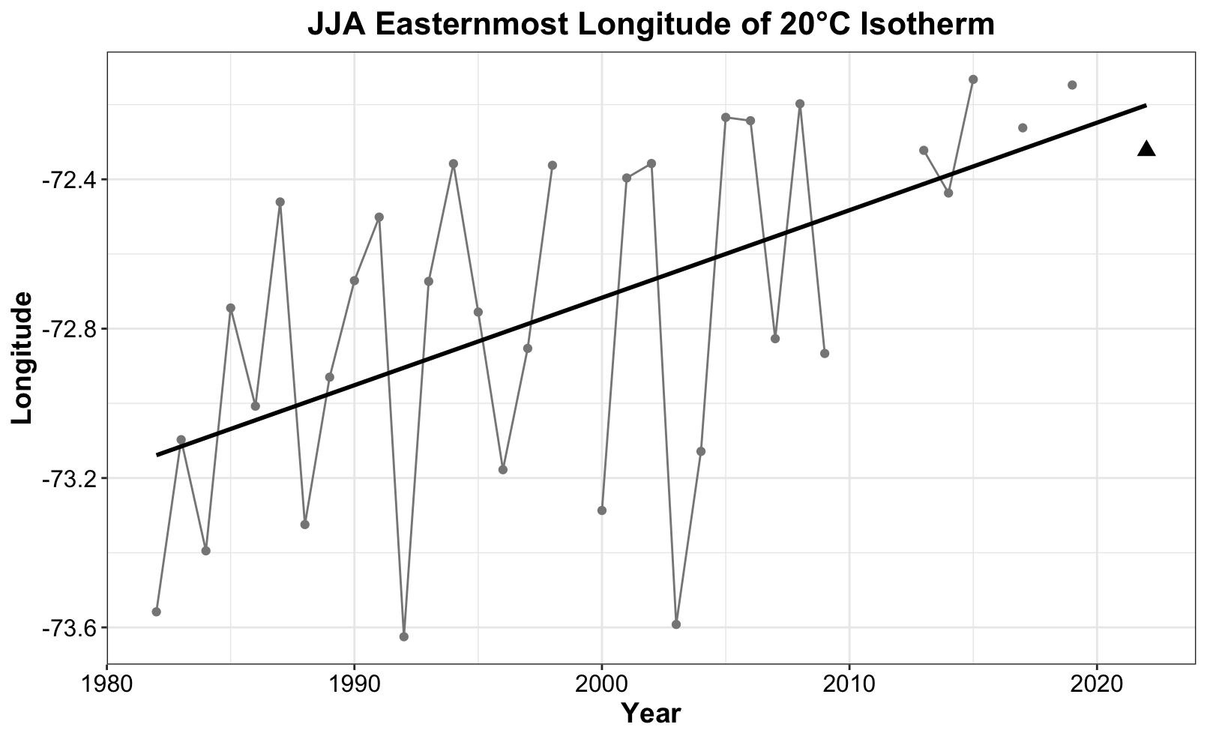Figure 14. Easternmost longitude of the 20°C surface isotherm during summer (June, July, August). Missing data points indicate years where the 20°C surface isotherm was outside of the NYB to the northeast. Figure 15 shows this northeastward progression in map view.

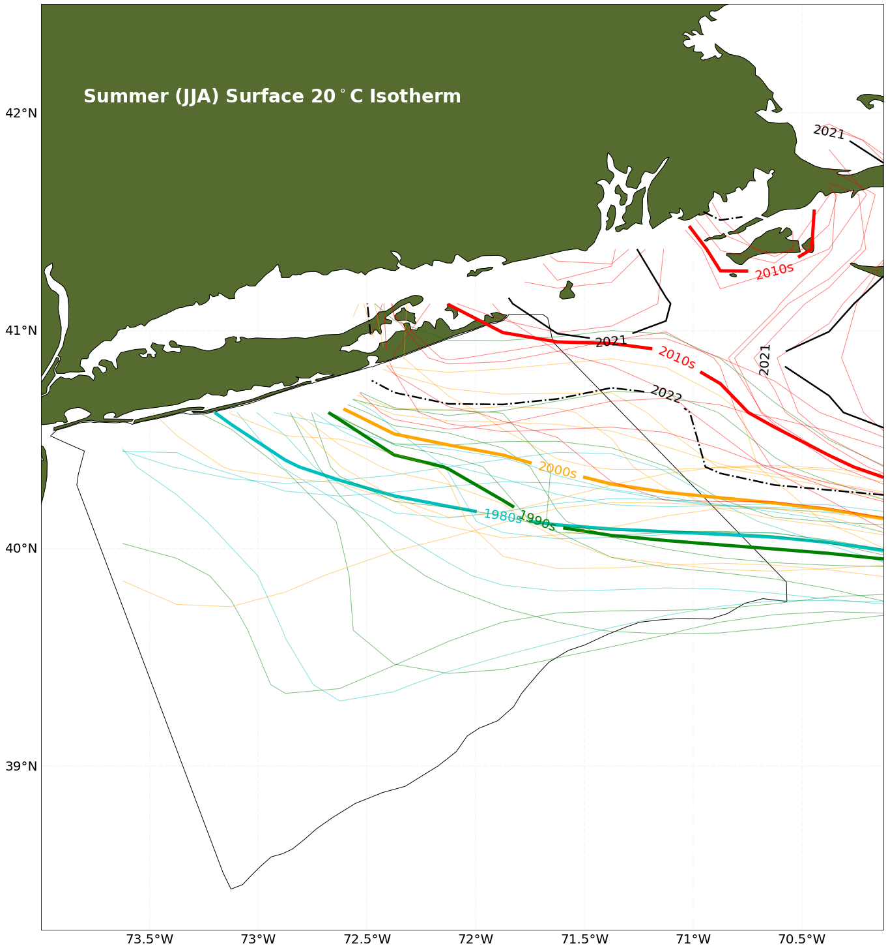

Figure 15. Summer (June, July, August) surface 20°C isotherms are plotted from satellite SST data with the 1980’s shown in blue, the 1990’s in green, 2000-2009 in yellow and 2010-2019 in red. Decadal averages are shown in the thick blue, green, yellow, and red lines. 2021 is shown in the solid black line and 2022 in the dashed black line.

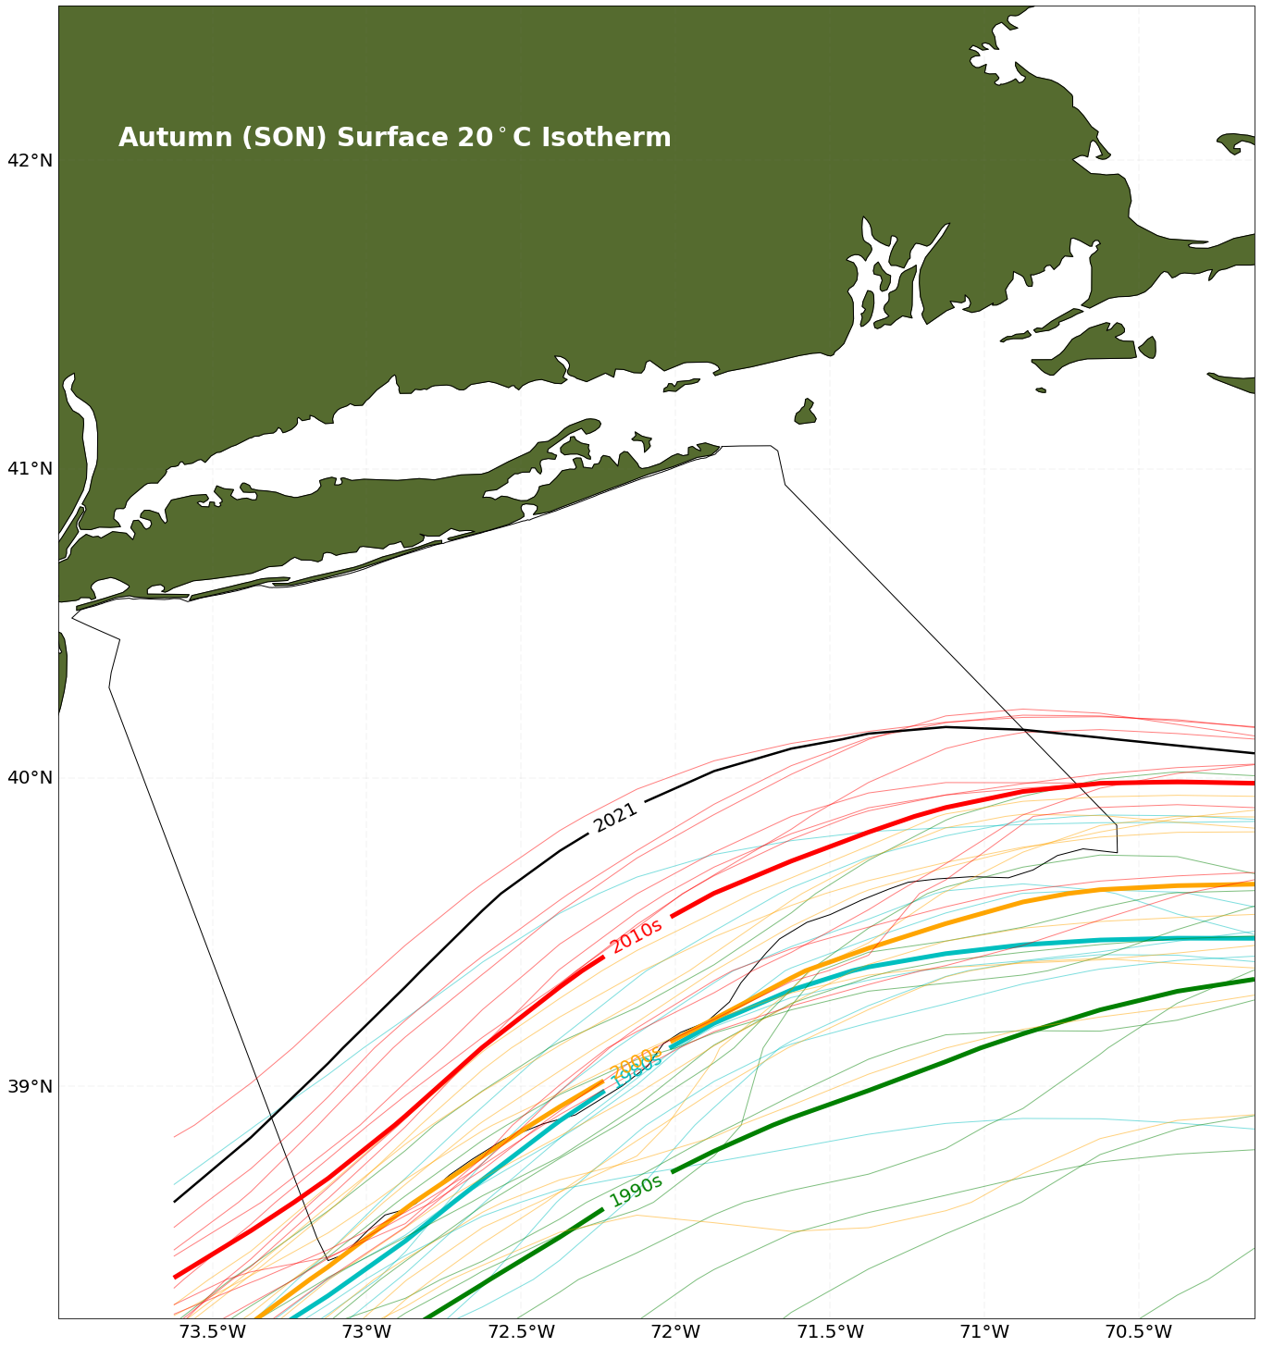

Figure 16. Autumn (September, October, November) surface 20°C isotherms are plotted from satellite SST data with the 1980’s shown in blue, the 1990’s in green, 2000-2009 in yellow and 2010-2019 in red. Decadal averages are shown in the thick blue, green, yellow, and red lines. 2021 is shown in the solid black line.

### Lobster Thermal Habitat

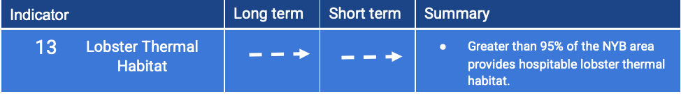

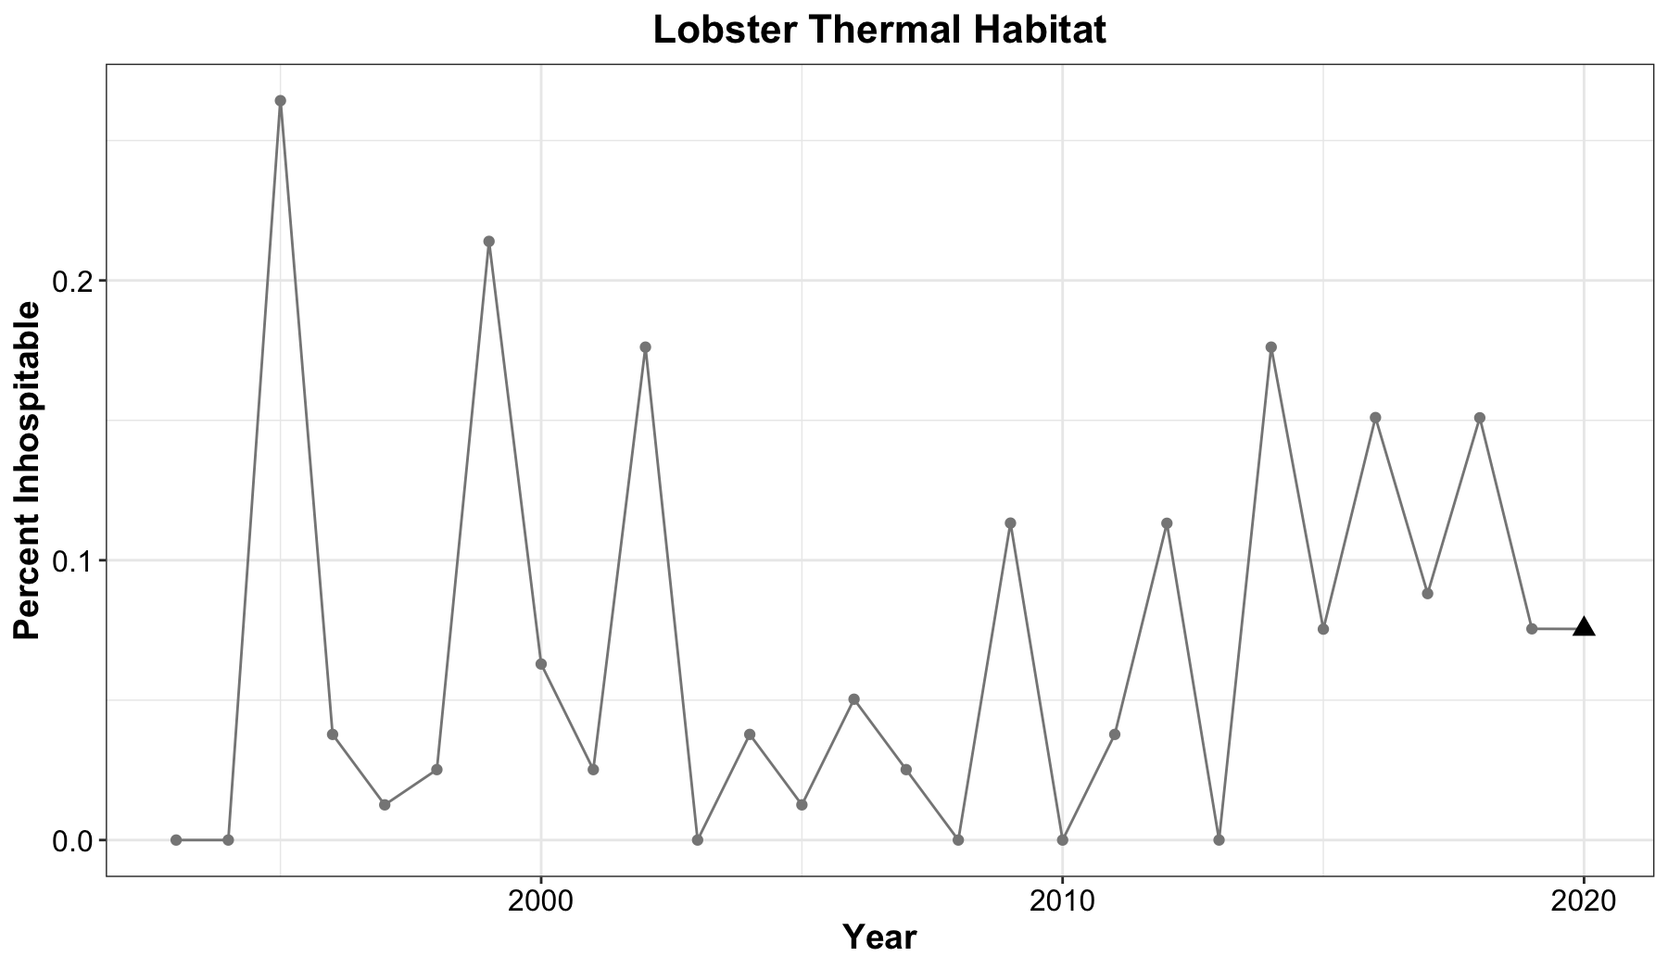

Figure 17. Yearly values for the percentage of the NYB that contains bottom temperatures greater than 20°C (inhospitable to lobster) are shown above. All values are less than one percent.

## Marine Community

### 

### Summary

Many marine organisms, from plankton to squid, are showing interesting trends in the NYB. *Calanus finmarchicus*, an abundant zooplankton which provides an important food source for many organisms including marine mammals, increased in the last three years. This in turn contributed to the downward trend in the small to large copepod ratio indicator. Longfin squid has been decreasing during the spring but increasing during the fall, with the largest longfin squid values seen in 2021. These trends do not hold for shortfin squid. In the last decade, during the increase in marine heatwave days, black sea bass, a warm water species, has markedly increased. Also showing increases are temperature preference of the fish community, and fish species richness. Summer flounder have also increased in the NYB. This species tends to move offshore during the winter months; therefore increases during spring and fall could be due to earlier onshore movement during warmer springs and later offshore movement during warmer autumns.



### Monthly Mean Surface Chlorophyll

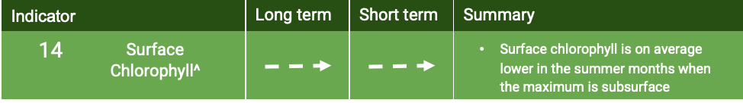

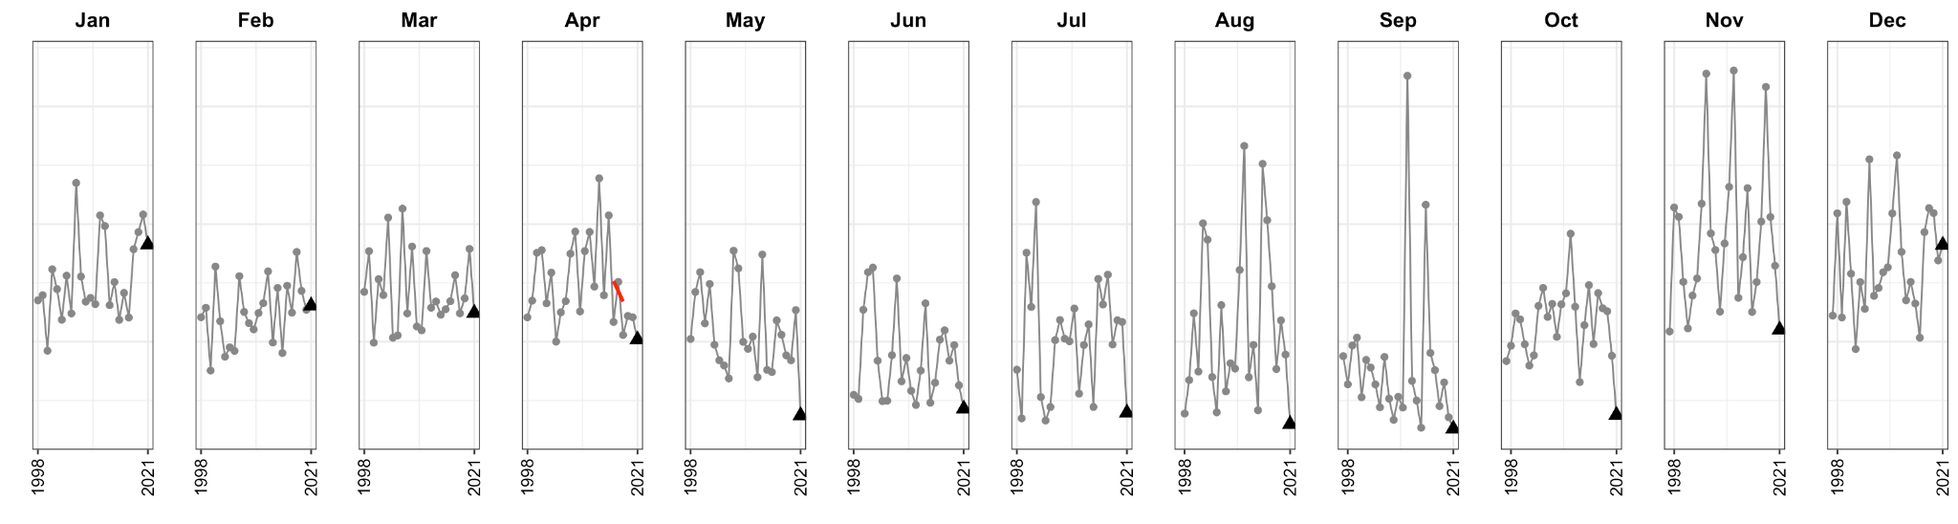

Figure 18. Monthly mean surface chlorophyll from satellite observations, starting with January on the left through December on the far right.

### Calanus finmarchicus abundance

### 

### 

Figure 19. *Calanus finmarchicus* abundance anomaly from ECOMON data. *Calanus finmarchicus* has increased over the last three years.

### Copepod Size Index

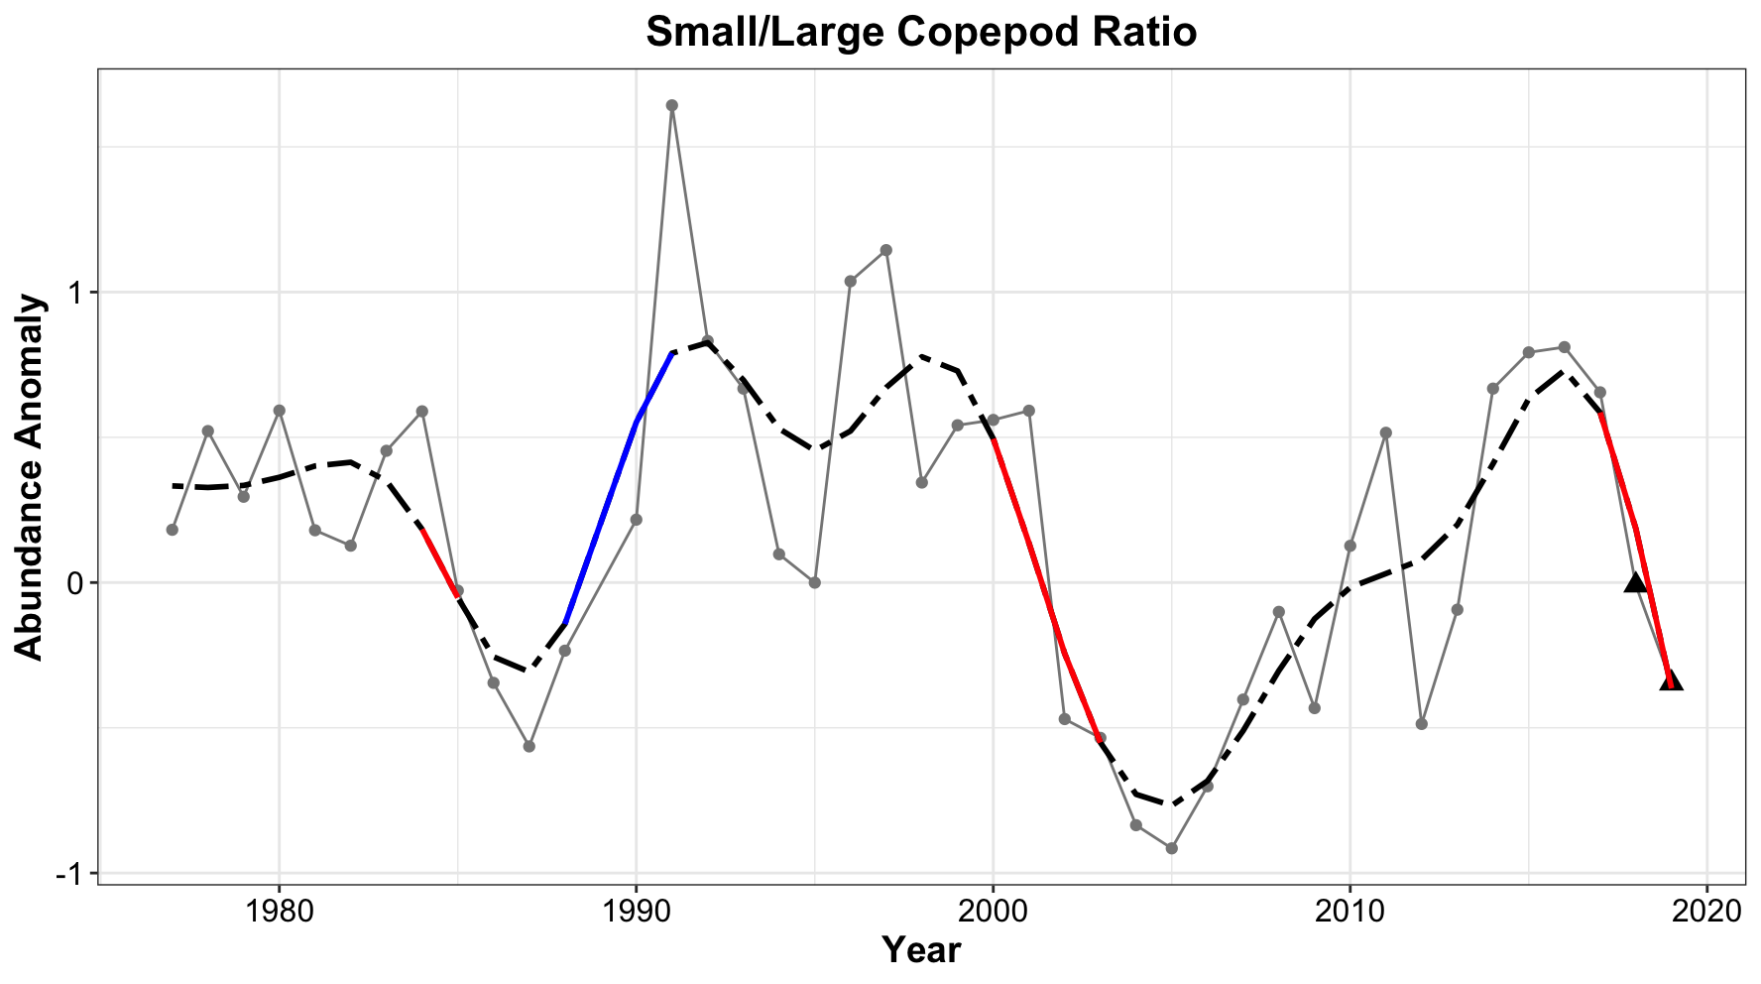Figure 20. Small to large copepod ratio. The ratio has decreased in the last three years due to the increasing presence of *Calanus finmarchicus*.

### 

### Commercially Important Invertebrates

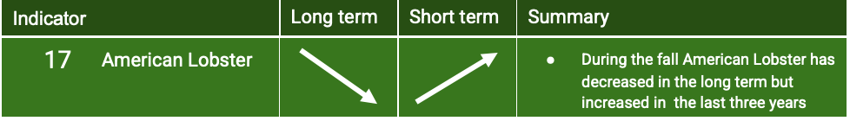

### 

### 

Figure 21. American lobster biomass during the spring (top) and fall (bottom) NOAA bottom trawl survey. Lobster biomass has shown a decreasing trend during autumn since the 1970s.

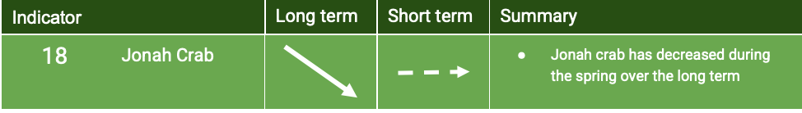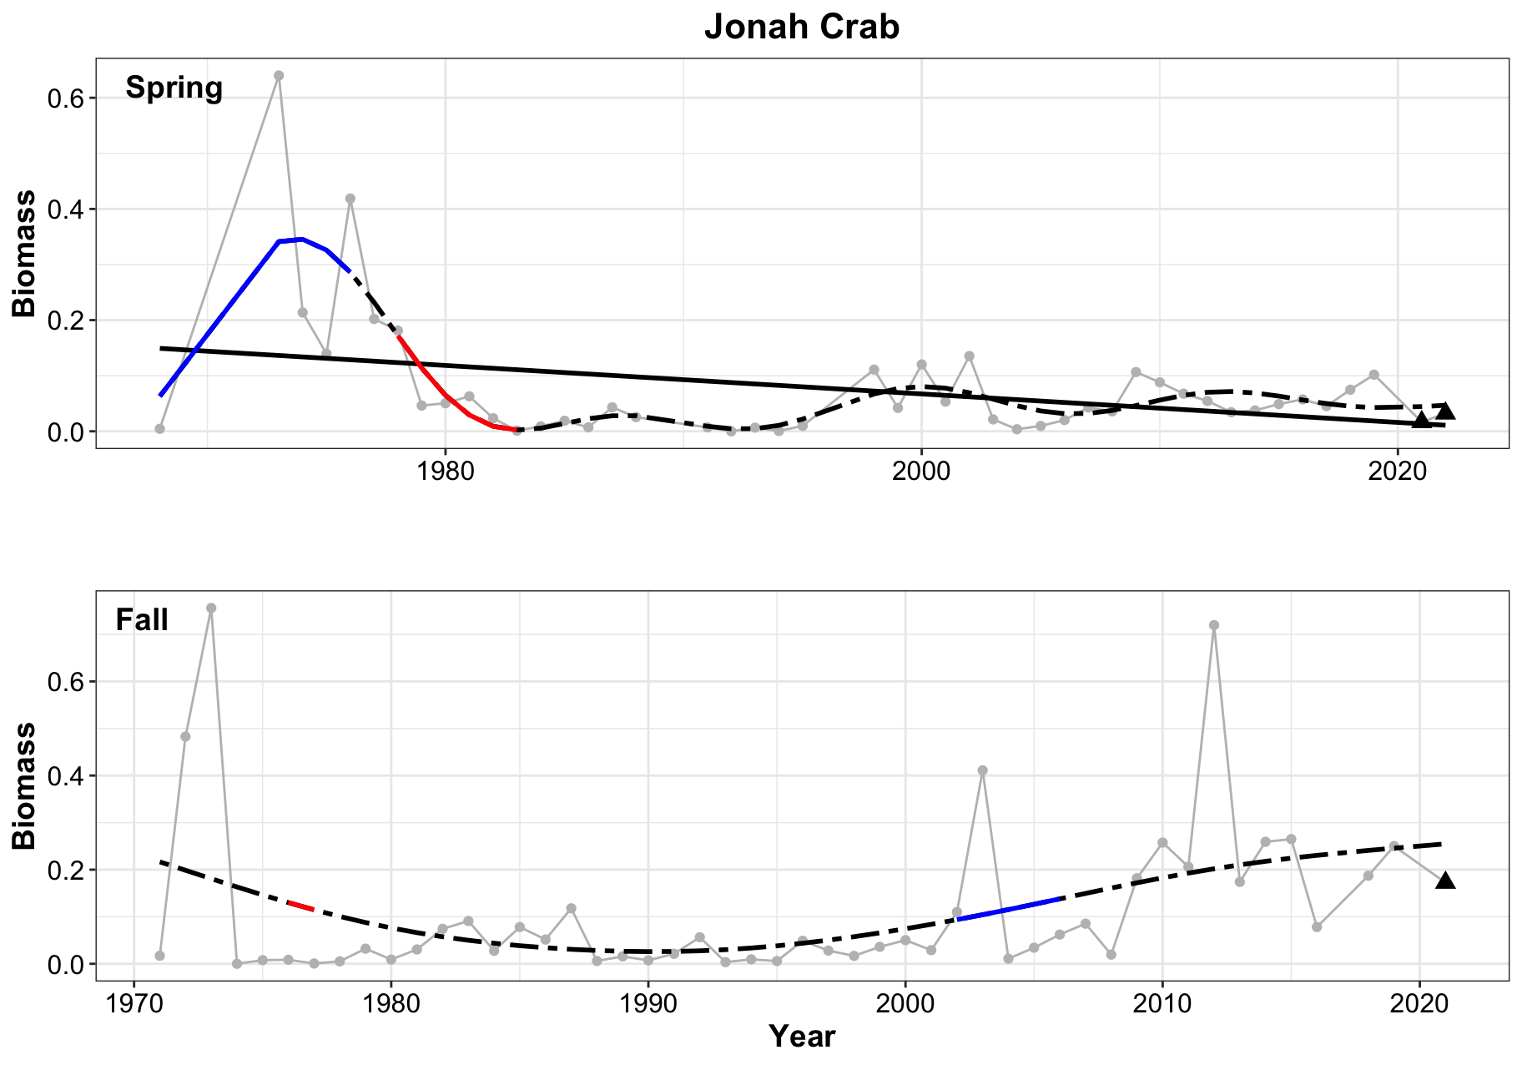Figure 22. Jonah crab biomass during the spring (top) and fall (bottom) NOAA bottom trawl survey. After a peak in abundance during the 1970s Jonah crab biomass has decreased in the spring. It has also decreased in the fall but shows an increase later in the time series after 2010.

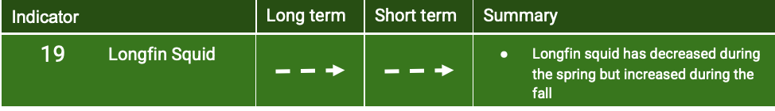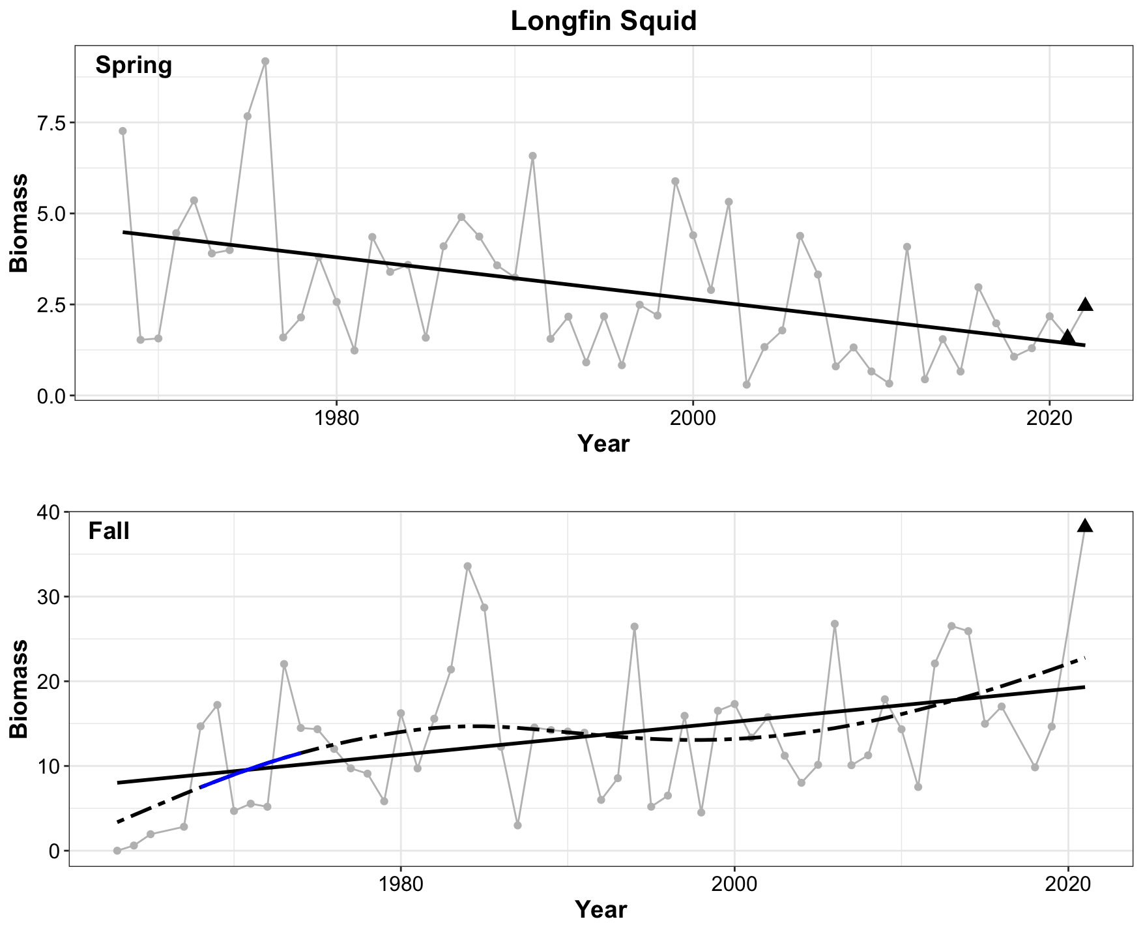Figure 23. Longfin squid biomass during the spring (top) and fall (bottom) NOAA bottom trawl survey. Longfin squid biomass has decreased during the spring while increasing during the fall. The largest values for longfin squid biomass since the beginning of the data collection in the 1960’s occurred in the autumn of 2021.

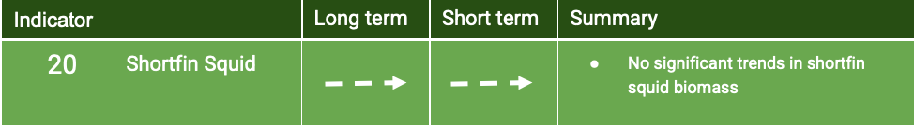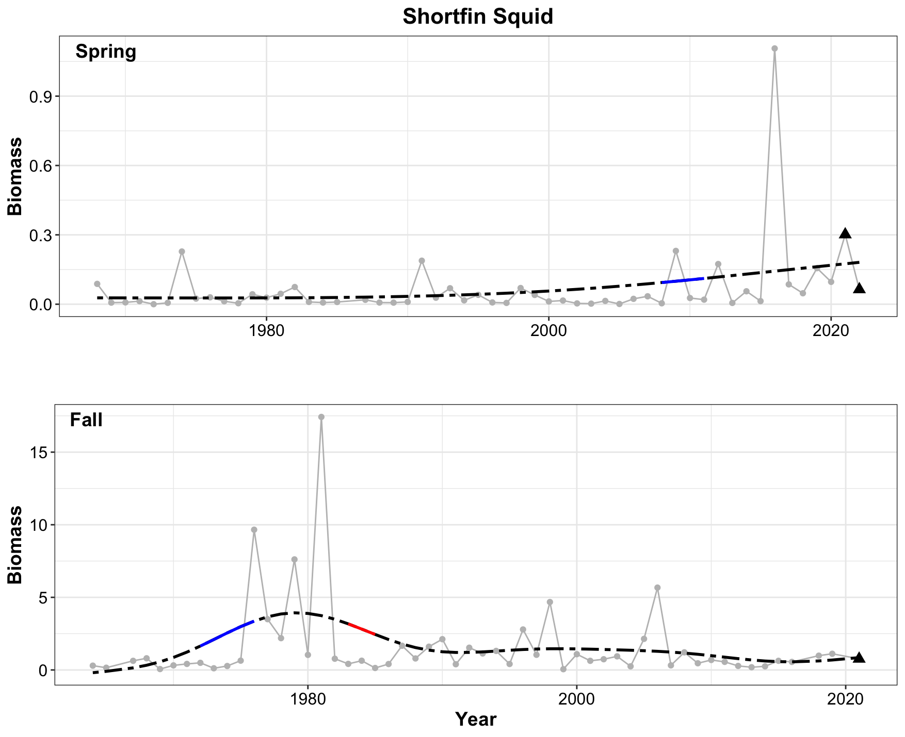Figure 24. Shortfin squid biomass during the spring (top) and fall (bottom) NOAA bottom trawl survey. Shortfin squid do not present any strong trends over the course of the timeseries.

### Forage Species Biomass

### 

Figure 25. Forage species biomass during the spring (top) and fall (bottom) NOAA bottom trawl survey. Forage species biomass increased during the autumn in the 1970s and decreased in the 1980s.

### Aggregate Feeding Groups

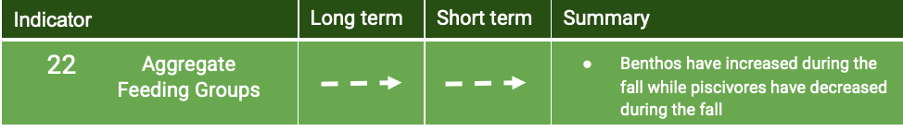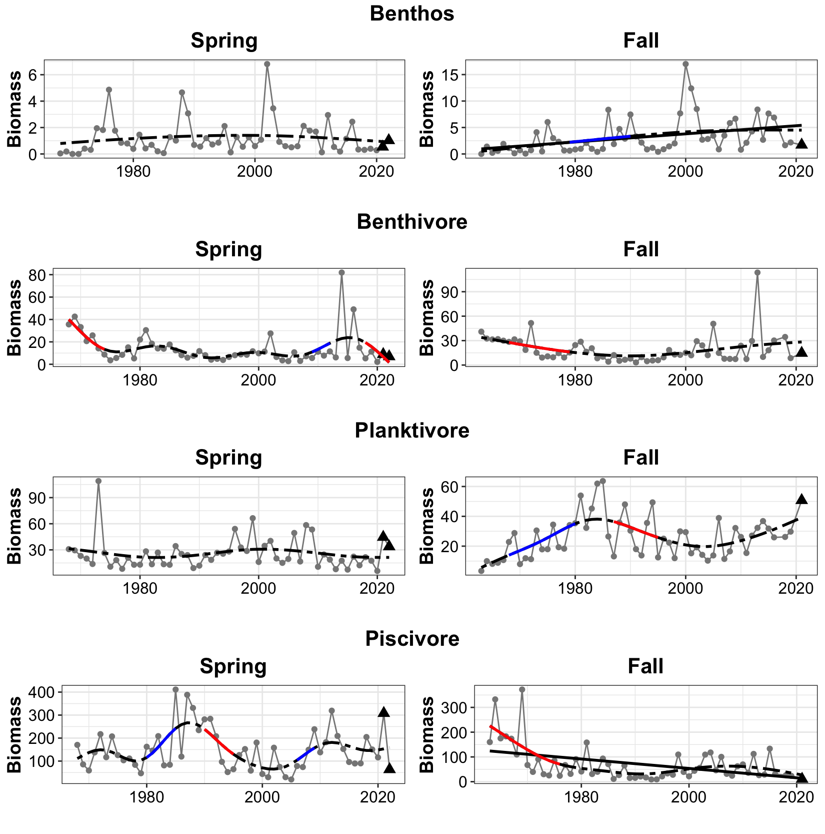 Figure 26. Spring (left) and fall (right) biomass are shown for benthos (top), benthivore (second from top), planktivore (second from bottom), and piscivore (bottom). Significant linear trends are seen in the benthos increase during the fall and the piscivore decrease during the fall. The decrease in benthivores and piscivores reflects overfishing of large benthic fishes in the 1960s and 1970s, the results of which are mirrored in subsequent indicators.

### Total Trawl Biomass

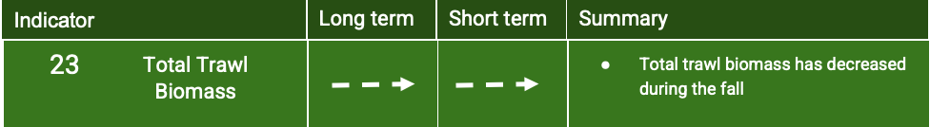

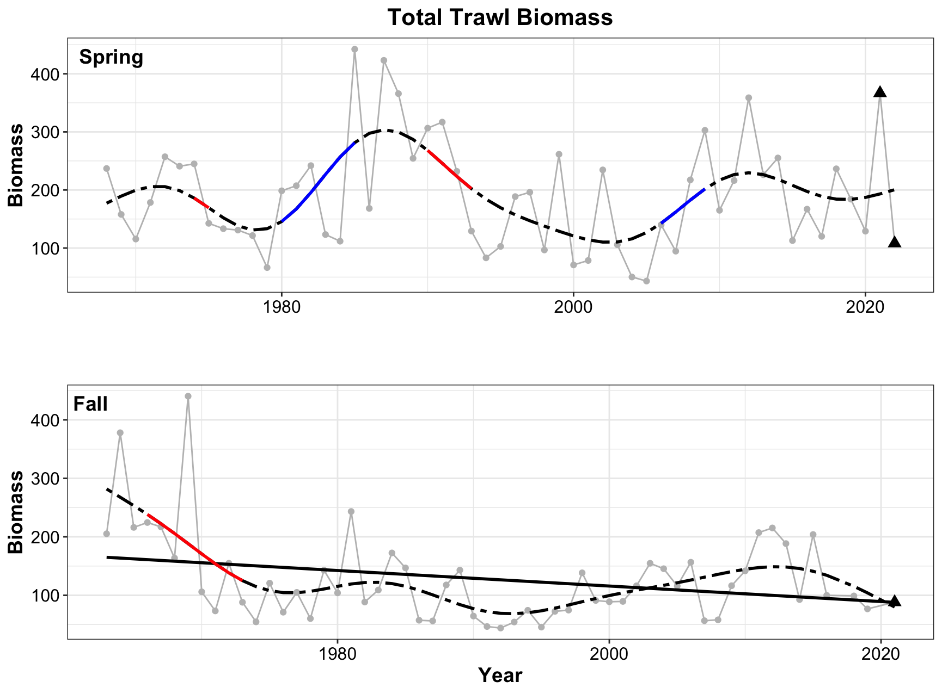

Figure 27. Total trawl biomass during the spring (top) and fall (bottom) NOAA bottom trawl survey. Total trawl biomass has been variable in the spring and shows a linear decrease during the autumn.

### Ratio of northern to southern species, finfish, and macroinvertebrates

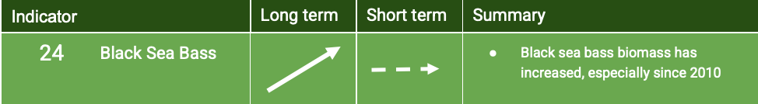

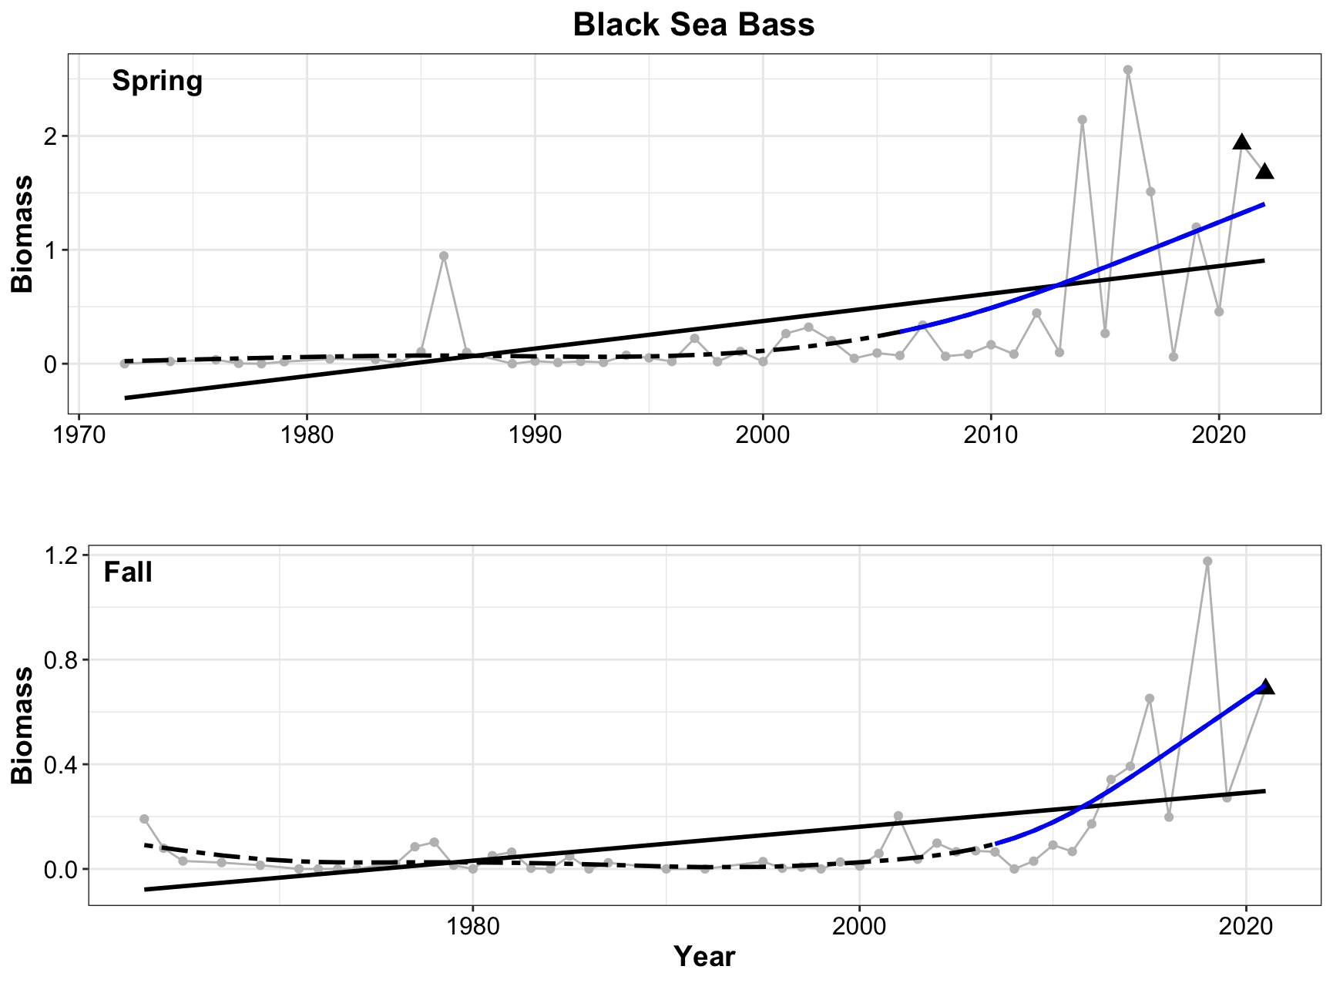

Figure 28. Black sea biomass during the spring (top) and fall (bottom) NOAA bottom trawl survey. Black sea bass biomass has been increasing both in the spring and fall with large increases starting in the mid 2000s.

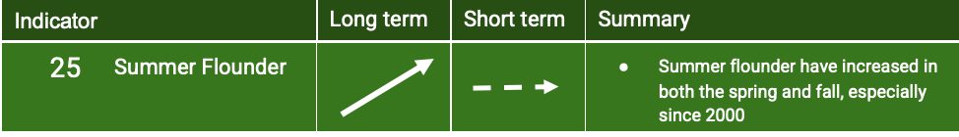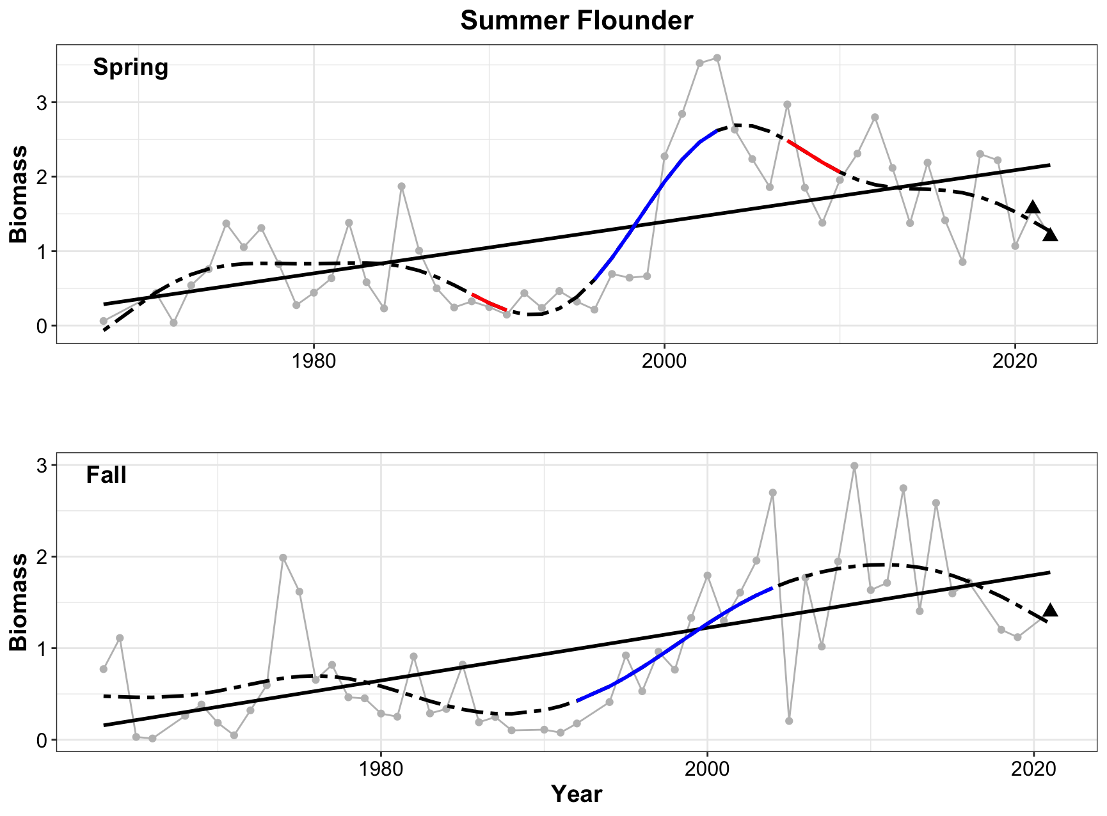

Figure 29. Summer flounder biomass during the spring (top) and fall (bottom) NOAA bottom trawl survey. Summer flounder has increased in both the spring and fall with the largest biomass occurring after 2000 for both seasons.

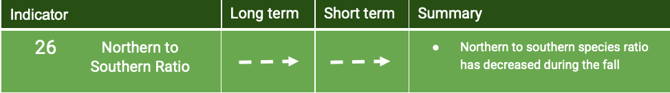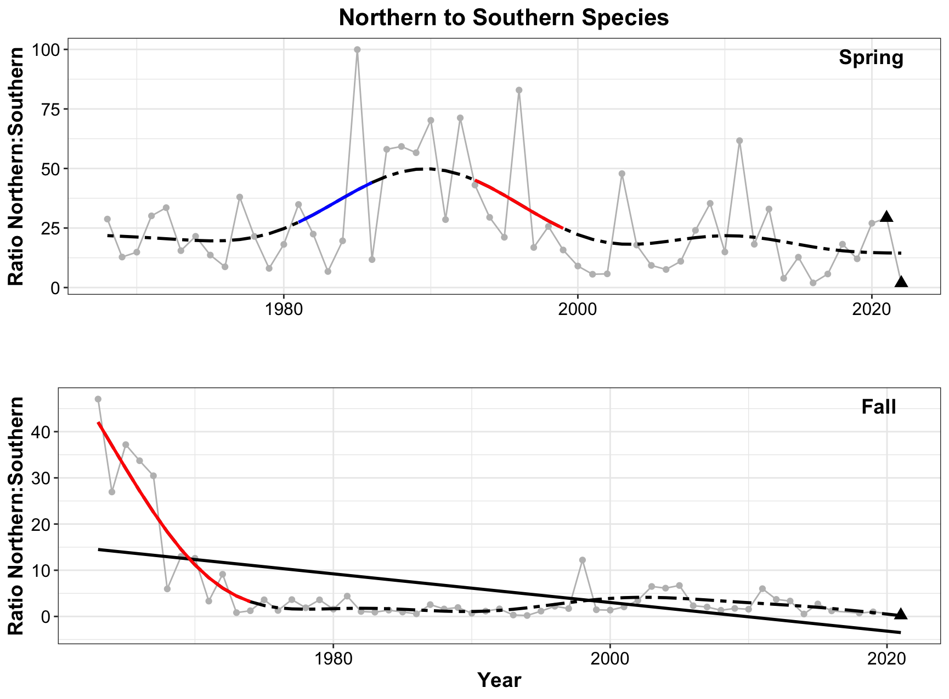

Figure 30. Ratio of northern to southern species during the spring (top) and fall (bottom) NOAA bottom trawl survey. The ratio of northern to southern species has dropped off significantly during the autumn from a high in the early 1970s to a very steady low through the 1980s to the present.

### 

### Ratio of Benthic to Pelagic Species

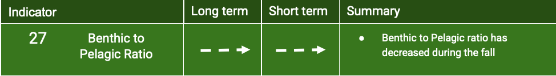

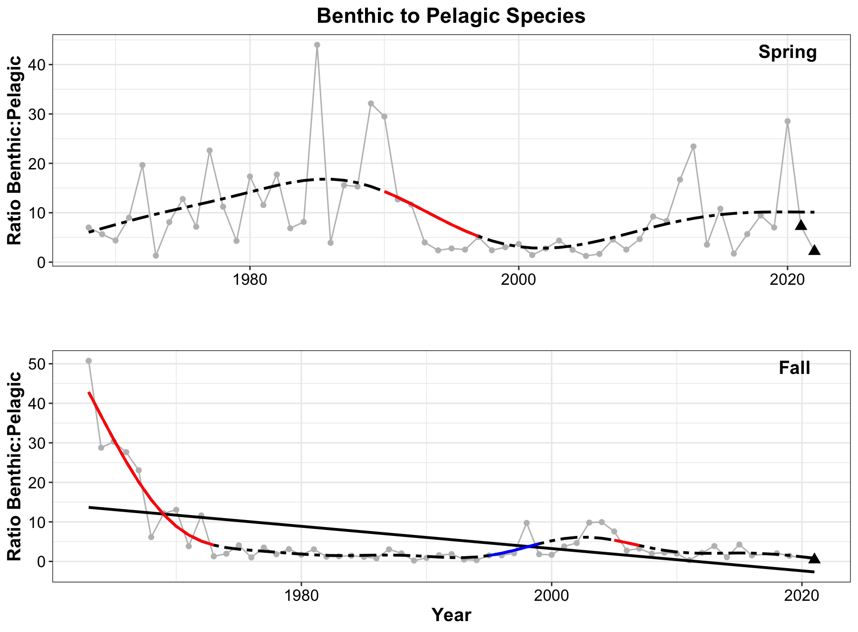

Figure 31. Ratio of benthic to pelagic species during the spring (top) and fall (bottom) NOAA bottom trawl survey. The ratio of benthic to pelagic species has dropped off significantly during the autumn from a high in the early 1970s to a relatively steady low through the 1980s to the present.

### Fish Species Richness

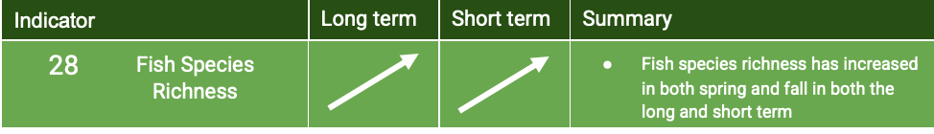

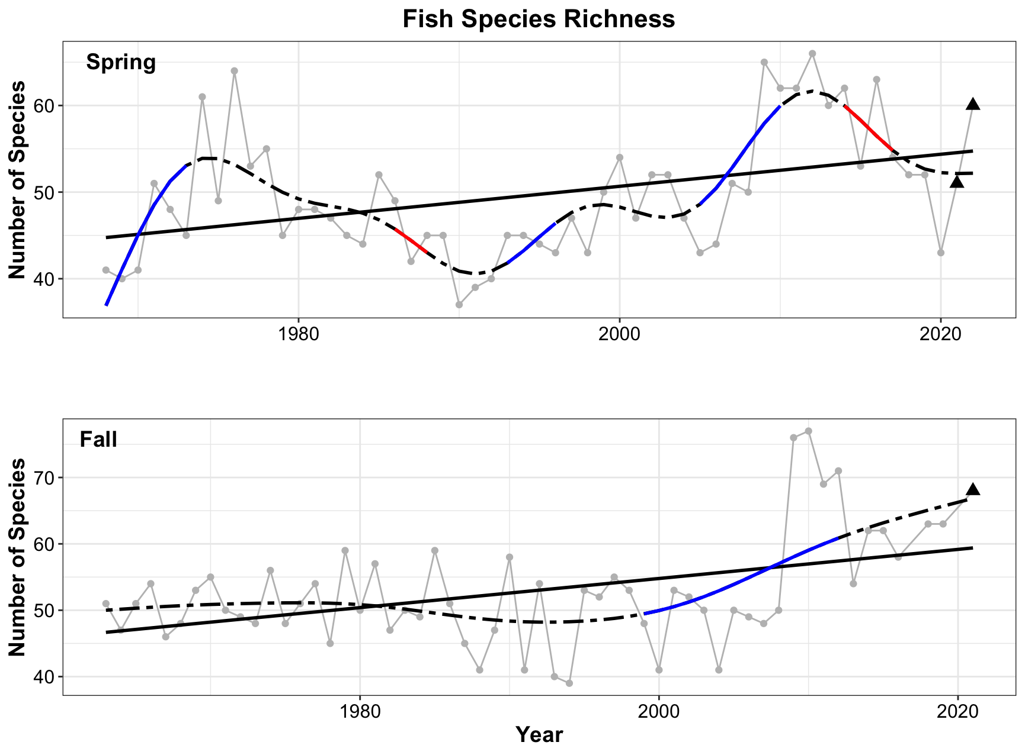

Figure 32. Fish species richness during the spring (top) and fall (bottom) NOAA bottom trawl survey. Fish species richness has increased in both the spring and fall over the course of the time series. The last three years have also shown increases in both seasons.

### 

### Average Trophic Level of the Fish Community

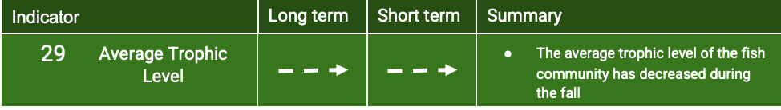

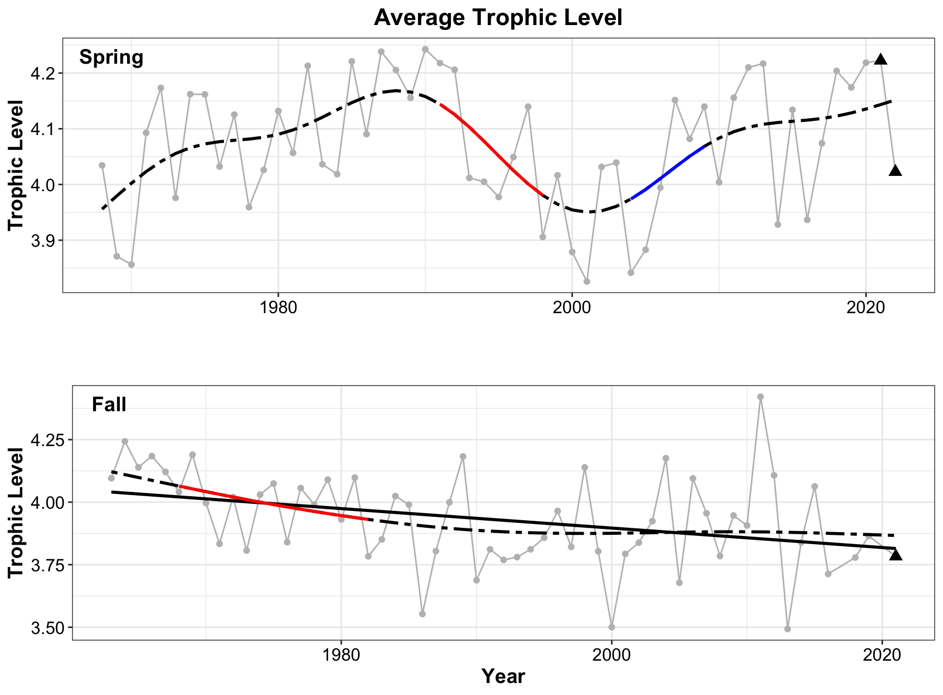Figure 33. The average trophic level of the fish community during the spring (top) and fall (bottom) NOAA bottom trawl survey. The trophic level has decreased during the fall since the start of the time series.

### 

### Temperature preference of the fish community

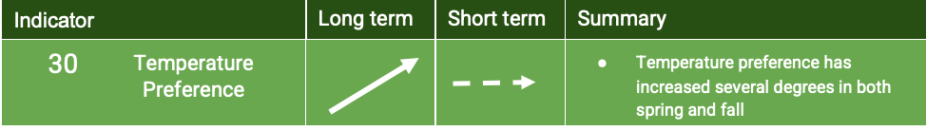

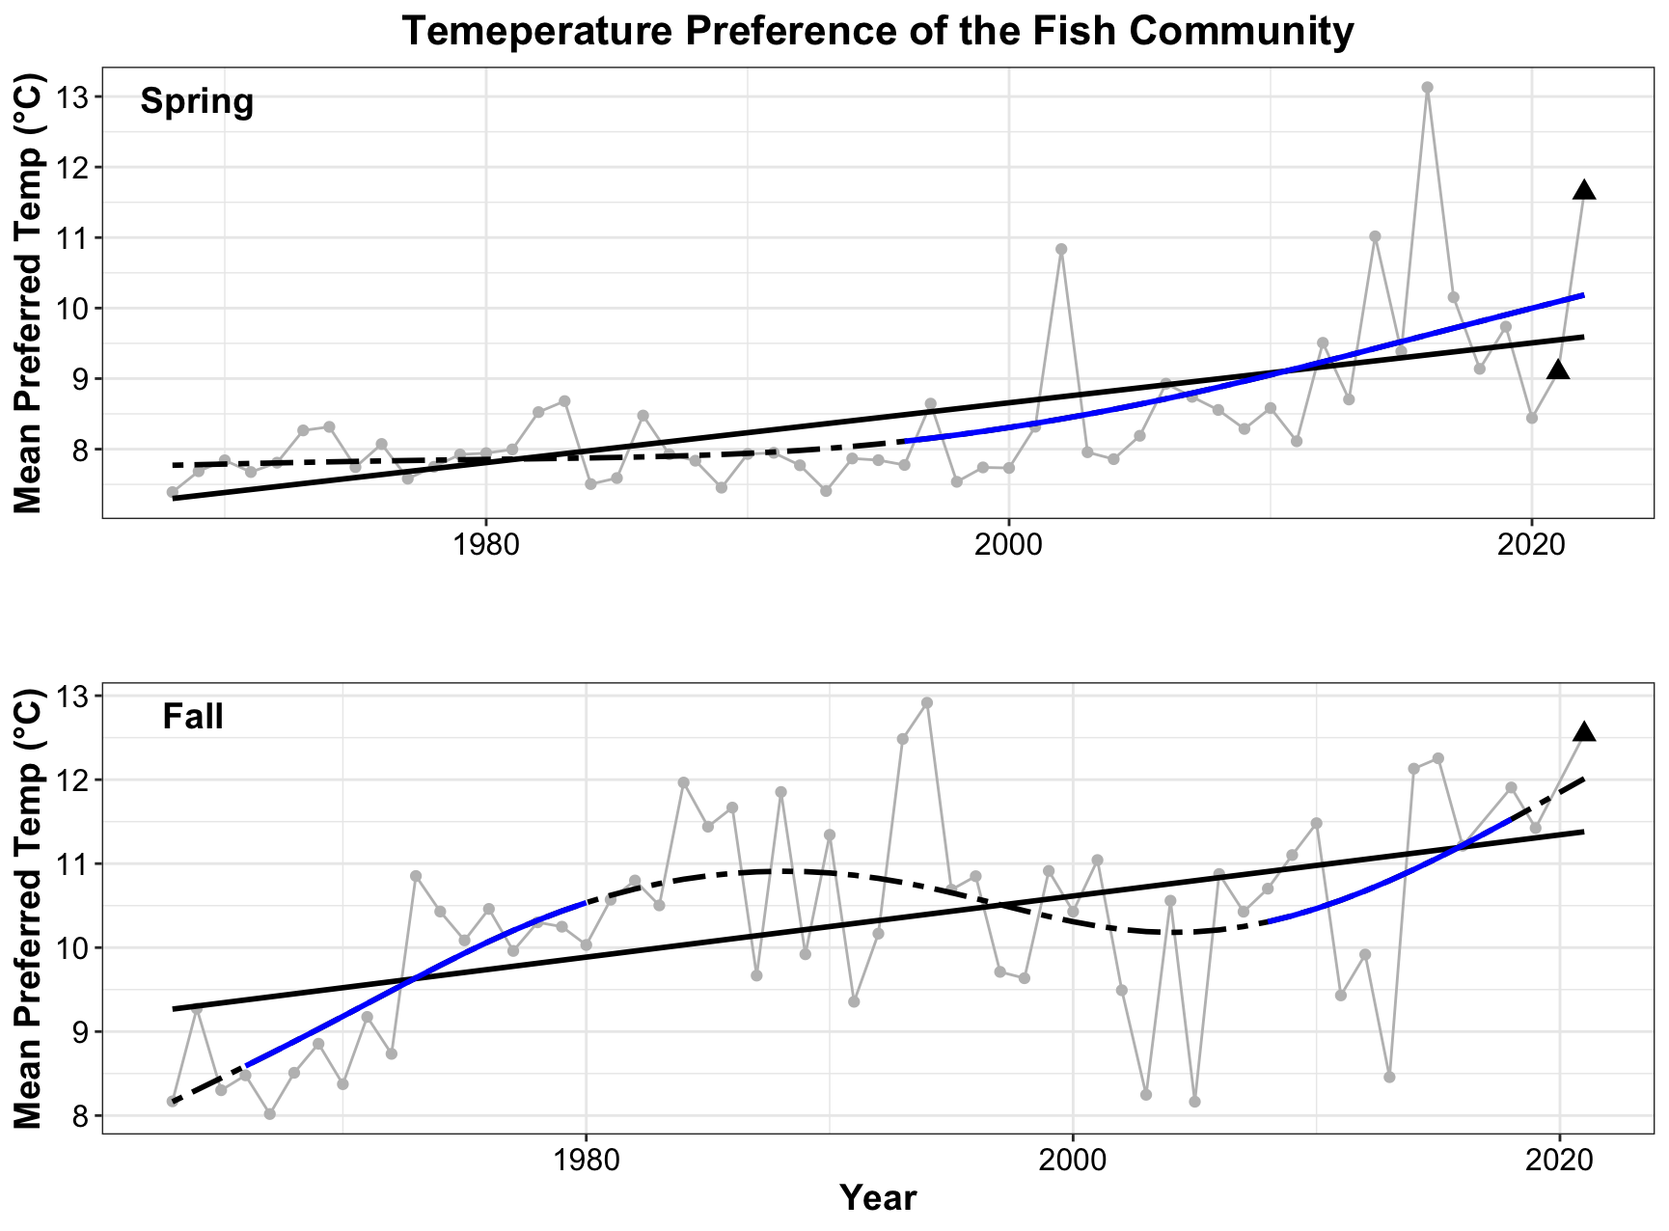Figure 34. The temperature preference of the fish community during the spring (top) and fall (bottom) NOAA bottom trawl survey. This temperature preference has increased during both seasons.

## Human Populations

### 

### Summary

The COVID19 pandemic proved detrimental to both recreational and commercial fisheries with 83% of commercial harvesters and 91% of charter or party boat operators experiencing adverse effects (NOAA Fisheries, 2021). The short term trends in recreational harvest and recreational effort both reflect these impacts with steep declines over the last three years. Recognizing the unique challenges facing the fishing community, 5.7 million dollars has been allocated to the Marine Fisheries Relief Program to assist commercial fishing and for-hire recreational fishing businesses (Governor Hochul Announces Distribution of $5.7 Million in Federal COVID-19 Relief to New York's Marine Fishing Industries, 2022).



### Commercial Fisheries Landings

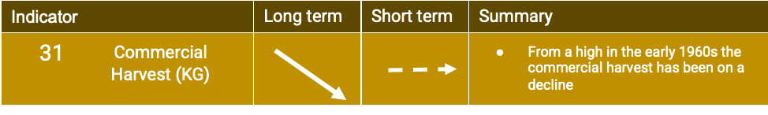

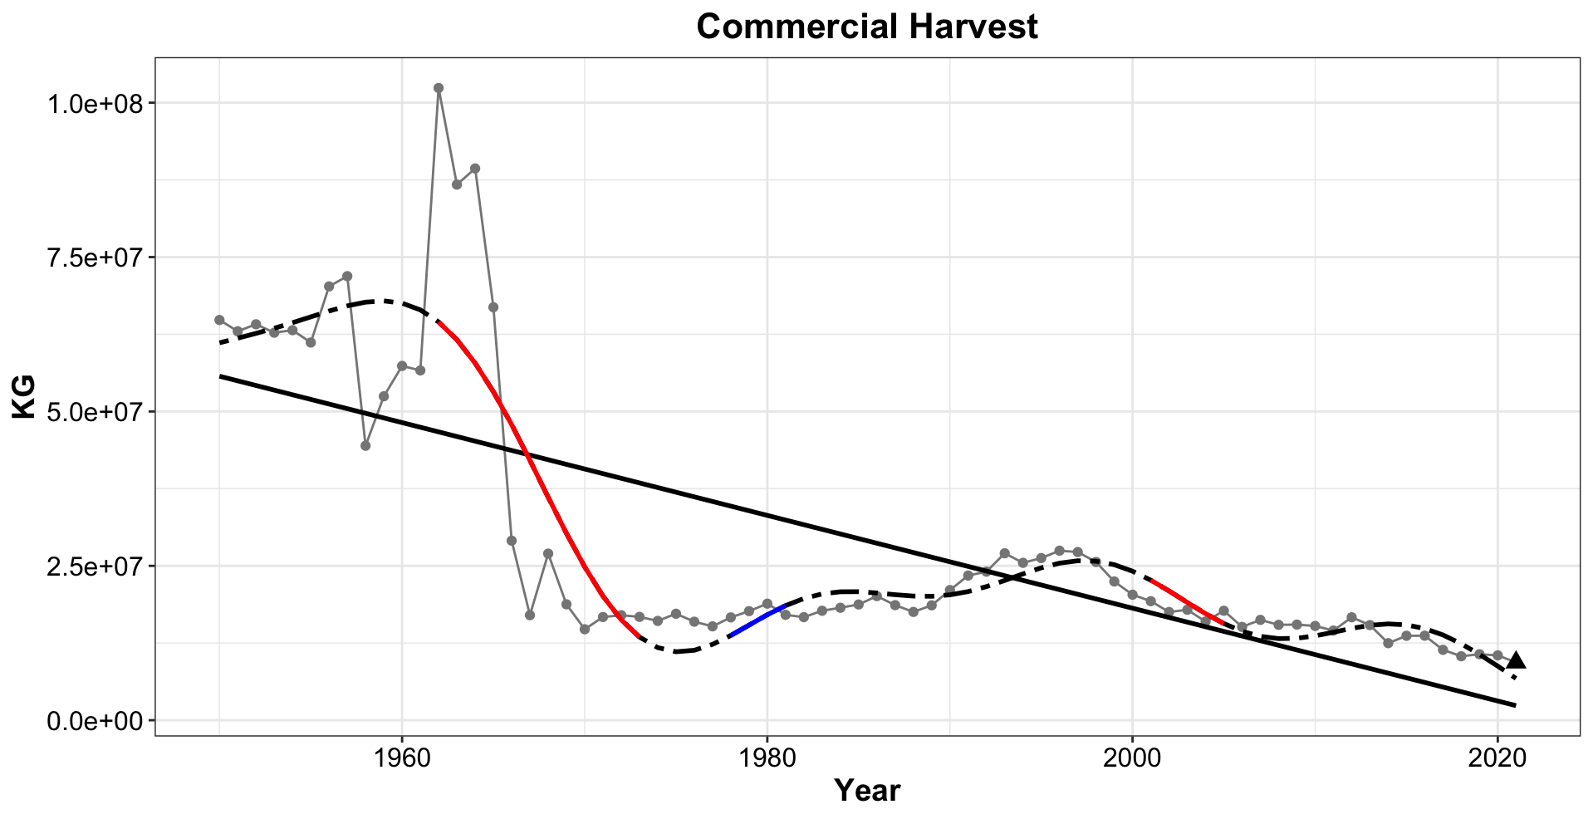

Figure 35. Commercial harvest in the NYB in kilograms. From a high in the early 1960s the commercial harvest has been on a decline.

### Commercial Landings Value

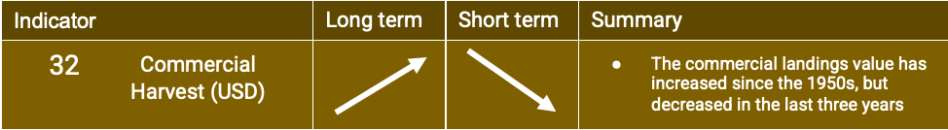

# 

Figure 36. Commercial harvest in US dollars accounting for inflation. The commercial landings value has increased since the 1950s. A decrease is present in the last three years.

### 

### 

### 

### 

### 

### 

### 

### 

### 

### 

### Recreational Harvest

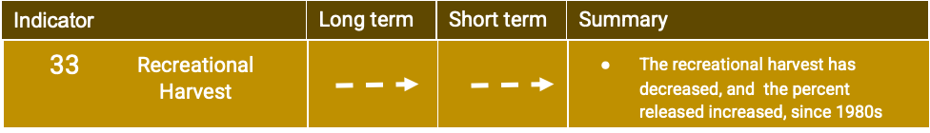

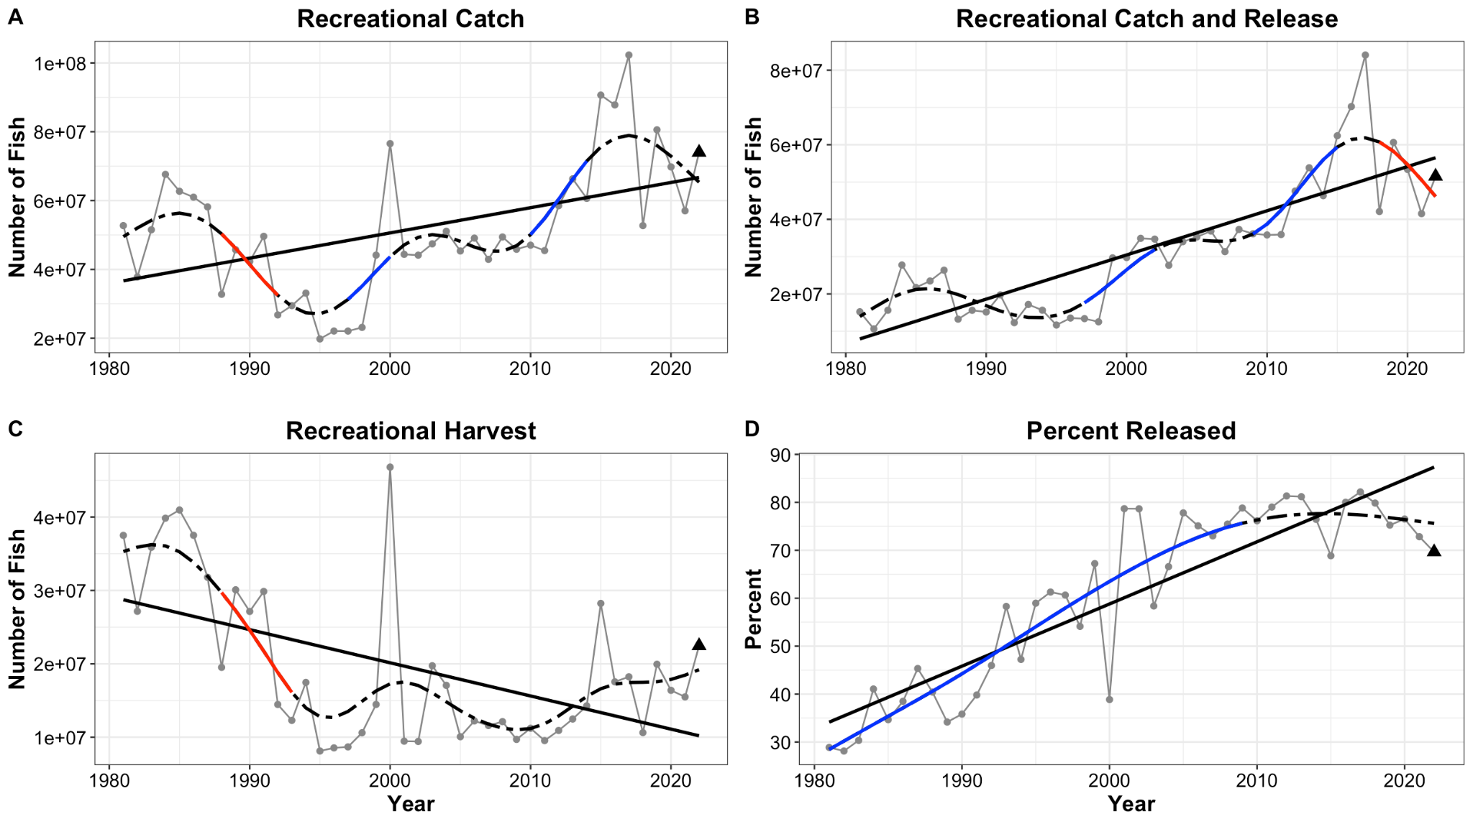

Figure 37. ***A.*** Recreational catch has been relatively stable over the last three years. ***B.*** Recreational catch and release shows a linear increase over the whole time series but has decreased in recent years ***C.*** Recreational harvest shows a linear decrease since the 1980s. ***D.*** The percent of fish released has more than doubled since the 1980’s. The Marine Recreational Information Program that monitors recreational fishing was partially suspended in 2020 and 2021 due to the COVID19 pandemic, data from these years may be incomplete. Data for 2022 is only available for January through October.

### Recreational Effort

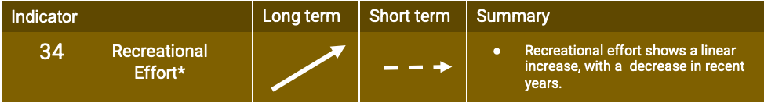

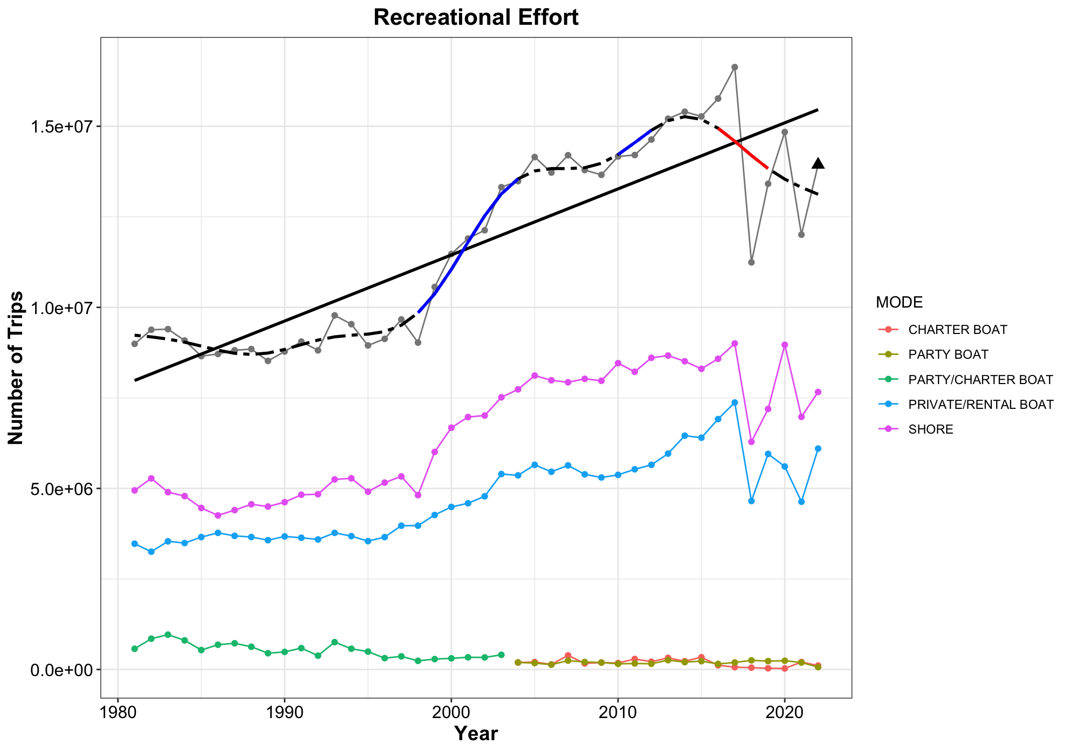

Figure 38. Total recreational effort in number of trips per year is shown in the black line. This is broken down based on the type of recreational trip: purple indicates fishing from shore, blue indicates private/rental boats, and green indicates party/charter boats. From 2004 onward the party and charter boats have been separated into party boat (brown) and charter boat (red). Recreational effort shows a linear increase over the whole time series. A drop is present starting in the 2010s through present. The data point for 2022 represents January through October only. During 2020 and 2021 portions of the Marine Recreational Information Program were suspended due to the COVID19 pandemic and data from these years is likely incomplete.

### Vessel Density

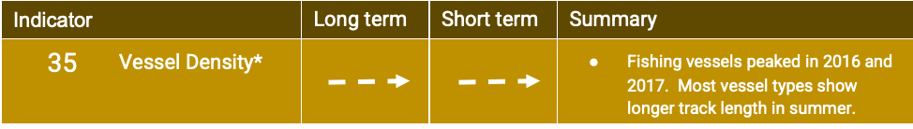

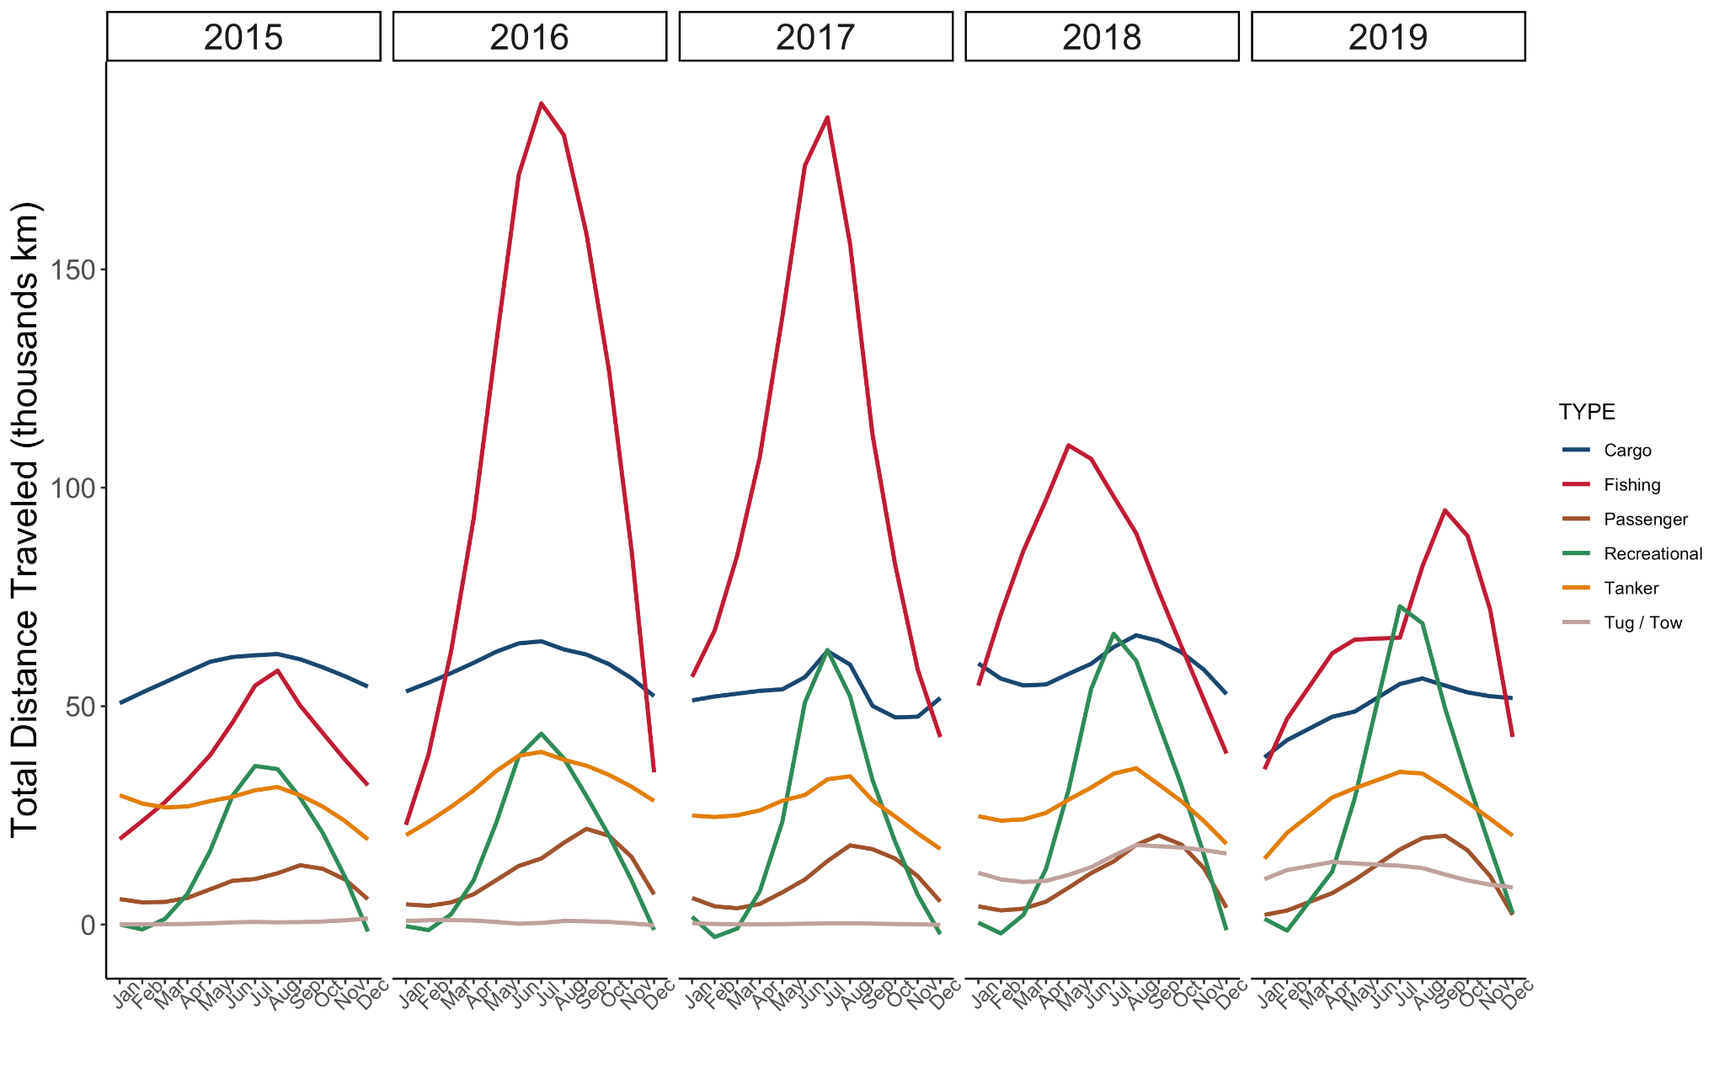

Figure 39. The total distance traveled in thousands of kilometers by different types of vessels is shown above from 2015 through 2019. Cargo vessels are shown in blue, fishing in red, passenger in brown, recreational in green, tanker in orange, and tug/tow in grey. Fishing vessels peaked in the years 2016 and 2017.

## 

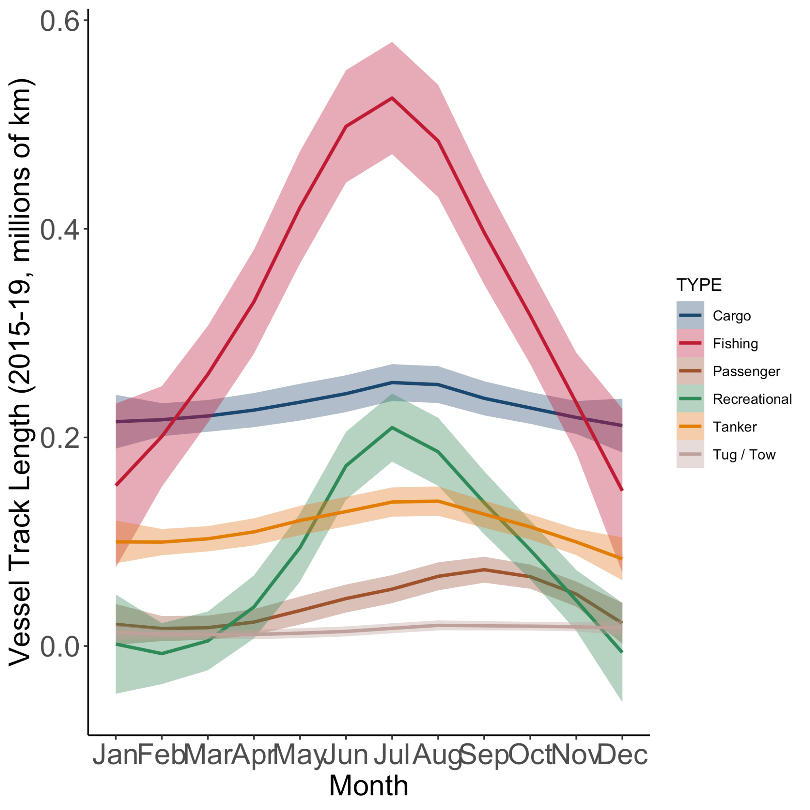

Figure 40. Seasonal cycle of vessel track length by vessel type with colors as in figure 39. Fishing, recreational, cargo, and tanker vessels peak in the summer months while passenger vessels peak slightly later in the early autumn.

### 

### Human Population of Long Island

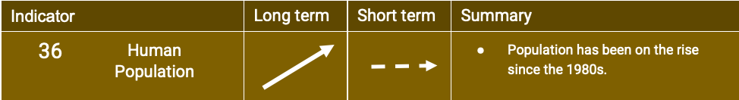

### 

Figure 41. The combined population of the four New York State counties that make up Long Island: Kings, Queens, Nassau, and Suffolk. Population has been on the rise since the 1980s.

### 

### Sea Level Risk for Long Island Communities

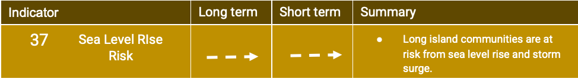The sea level risk and storm surge risk to New York municipalities remains the same as previous indicator reports. In general, most communities that are vulnerable to sea level risk are vulnerable to storm surge risk. However, there are some communities that are vulnerable to sea level rise, but not necessarily storm surge. This year we combined a social indicator of poverty developed by NOAA with the estimates of sea level rise risk to identify those communities that may have less resources to adapt to sea level rise. The social indicators developed by NOAA can be accessed here: <https://www.st.nmfs.noaa.gov/data-and-tools/social-indicators/>.

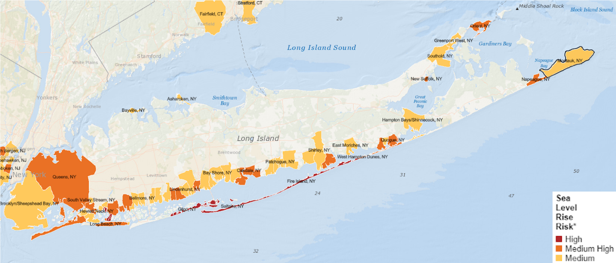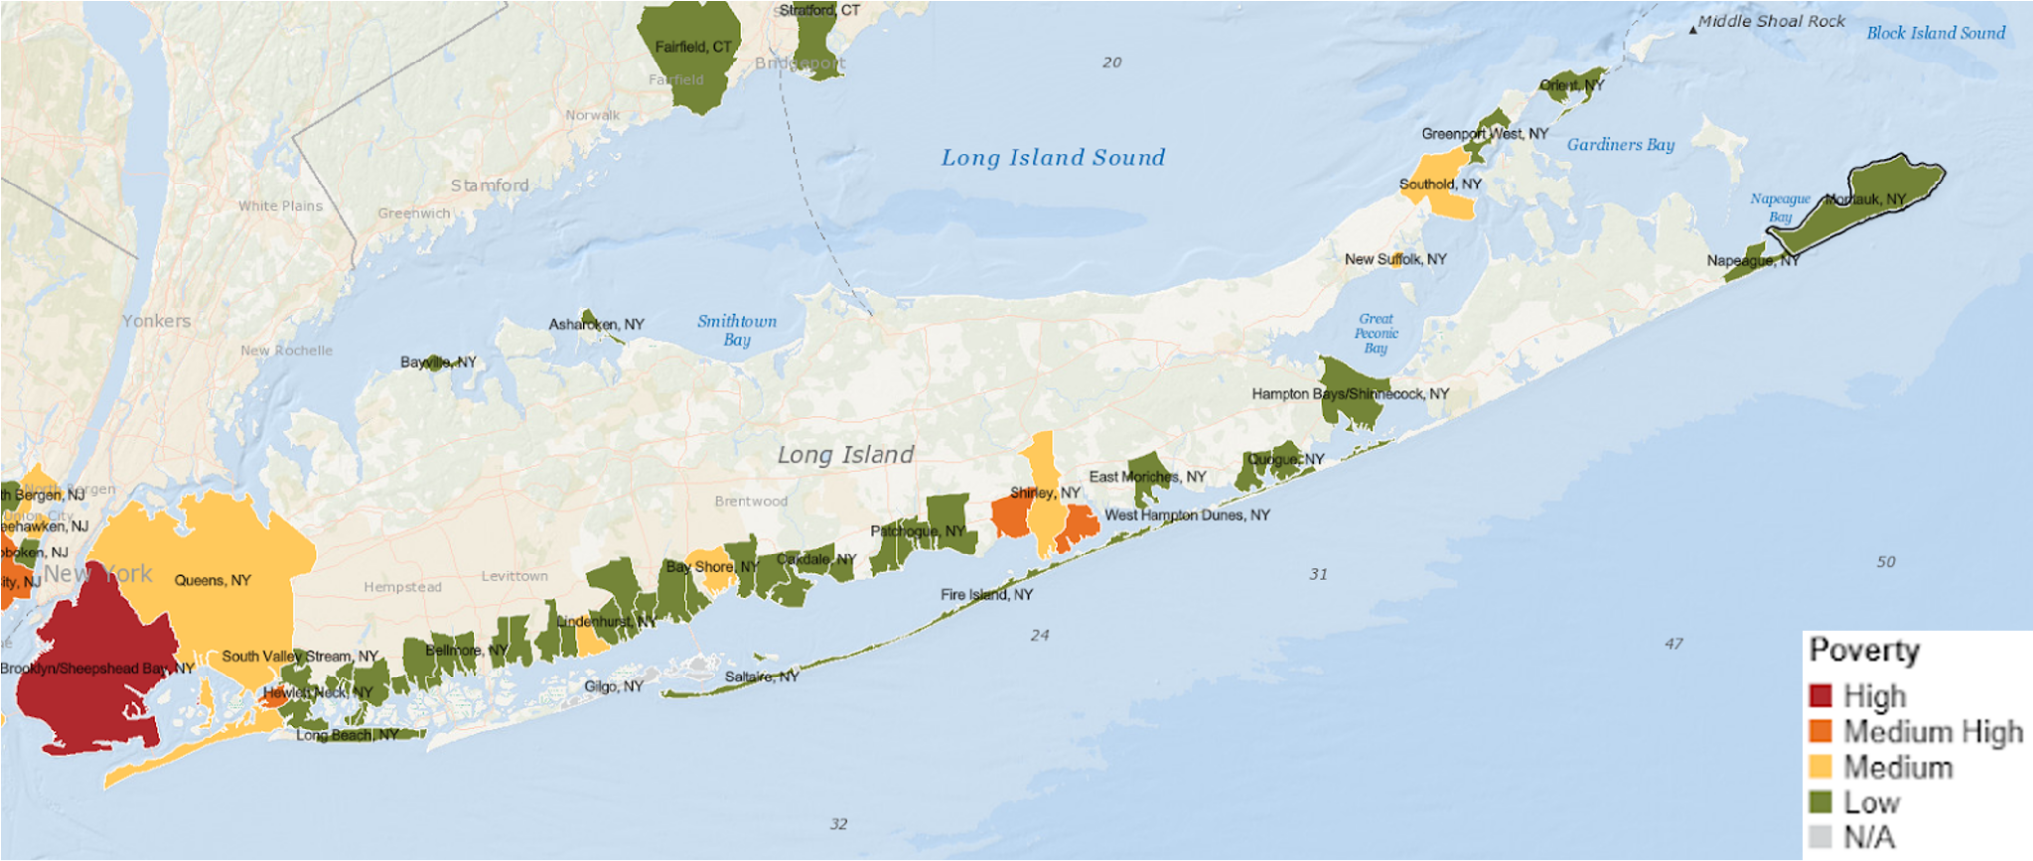

Figure 42. Sea level rise risk (top) with municipalities with low risk excluded for clarity. The associated poverty index categories for only those communities with medium to high levels of sea level rise risk (bottom). Note that all the communities with low sea level rise risk in the top panel are not shown in the bottom panel to focus on the poverty indicator for only communities with high risk of sea level rise. Montauk, NY is outlined in black because it has the highest engagement in commercial fishing in NY.

# Part II. Ongoing Indicator Development

### 

### Whale Body Condition

Body condition of upper trophic level species can provide an indicator of ecosystem health of the New York Bight as these species integrate across multiple trophic levels and across long time frames (Moore 2008, Bossart 2011, Hazen et al. 2019). Baleen whales are capital breeders that separate their breeding and feeding grounds, acquiring and storing energy while on the foraging grounds, and relying on that stored energy for the remainder of the year. Thus, the body condition of baleen whales reflects their energy stores, and changes in baleen whale body condition through time, and between foraging areas, can provide key information on whale health, changes to resource availability, and anthropogenic stressors (Bossart 2011, Bradford et al. 2012, Christiansen et al. 2020, Lemos et al. 2021). We are developing an indicator of baleen whale body condition in the NYB by integrating Unoccupied Aerial Systems (UAS), or drone, measurements with a scalable three-dimensional (3D) model to estimate baleen whale body volume, which provides a holistic means of assessing body volume (Hirtle et al. 2022). We are conducting field studies to quantify the body condition of humpback whales foraging in New York waters to detect and examine interannual changes in body condition. Further, we are using this indicator to make comparisons of body condition of humpback whales foraging in New York waters with those in different foraging areas across the North Atlantic.

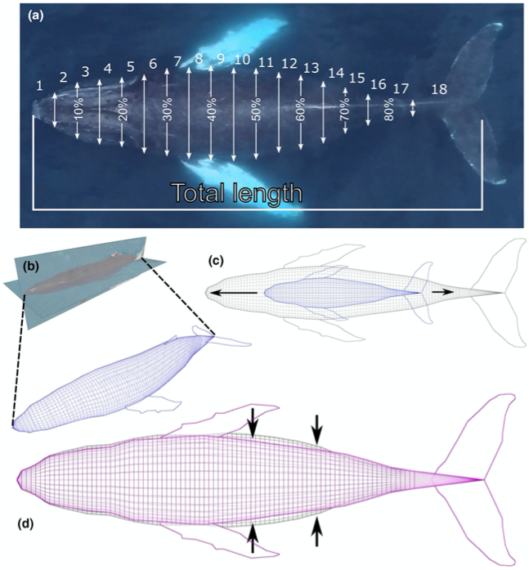

Figure 42. A workflow diagram of the model scaling process used to generate estimates of body volume, from Hirtle et al. (2022). (a) Width measurements (white arrows) and total length measurements are derived from Unoccupied Aerial System (UAS) images. Numbers between width measurements indicate percent total length from rostrum to fluke notch. Integers 1–18 indicate three-dimensional (3D) body segments corresponding to regions between width measurements. (b) The base 3D model is constructed using dorsal and lateral images. (c) The base model (blue) is scaled to length, conserving model proportions. (d) The model is scaled laterally and dorsoventrally to match corresponding width measurements and height-width ratios, resulting in the final model (purple). Black arrows indicate regions of greatest change relative to the base model.

Our analyses to date have highlighted the importance of accounting for age class and body size while assessing body condition, as smaller juvenile whales appear to put their energy into growing longer, rather than fatter, during the foraging season. This is particularly important in our study site as a large proportion of the whales we observe foraging in the NYB are juveniles (Stepanuk et al. 2021). We are therefore using the approach of Christiansen (2020) to account for body size, and to allow us to examine body condition in humpback whales using data from all individuals observed. Briefly, there is a strong and significant linear log-log relationship between body volume and body length (whales with a longer body length inherently have a larger body volume). We calculate a body condition index of individual whales observed in the NYB using residuals of this log-log relationship. Positive values of this index reflect better body condition than the average whale of the size body length, while negative values indicate worse body condition. However, developing reliable values of this metric requires a large sample size so as to have sufficient data to establish a strong relationship between body volume and body length as calculated residuals are strongly dependent on this relationship. We are therefore building up our dataset of baleen whale morphometrics so as to rigorously assess the relationships between body volume and body length. We anticipate that after acquiring measurements of approximately 80-100 individuals then we will be able to reliably calculate the body condition metric for all individuals.

### Odontocete Strandings

We examined trends in odontocete species strandings in New York from 1996-2021. Odontocetes are suitable study species for examining changes to the distribution of cetacean strandings through time as they are typically resident or weakly migratory and thus analyses are not complicated by migratory patterns, and because odontocetes are well represented in the strandings data.

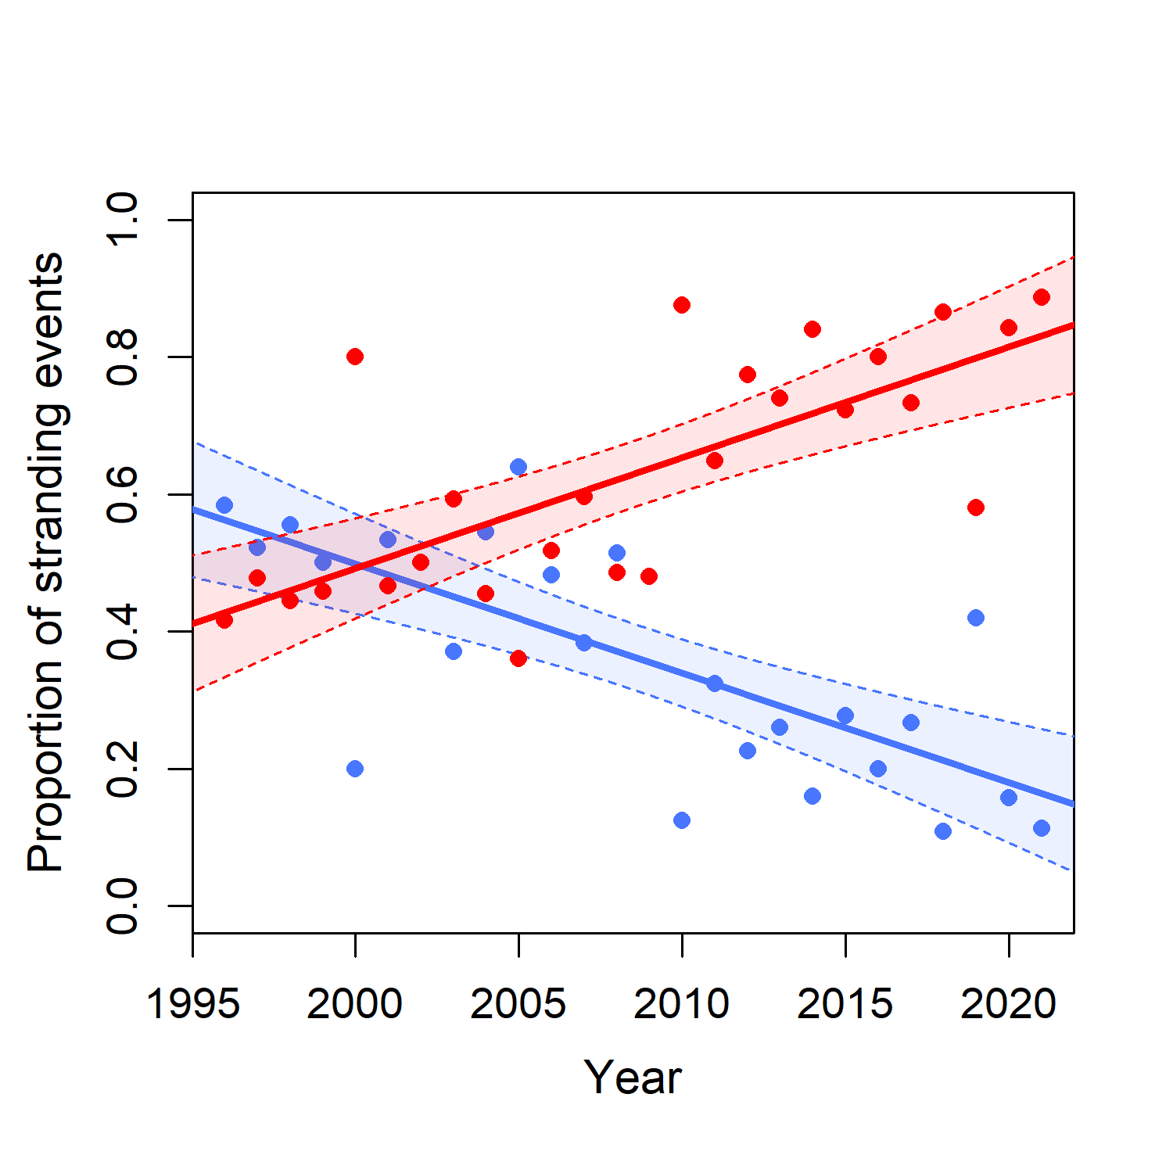

Figure 43. Proportion of strandings that were warm (red) or cold (blue) water species.

We followed the methods outlined in Thorne et al. (2022) to examine temporal trends in the species composition of odontocetes stranding in New York specifically. Briefly, we obtained Level A data from the National Marine Mammal Stranding Database, collated by the National Marine Fisheries Service. Level A data includes basic information such as species ID, location, and condition of the stranded information. We classified odontocete species as warm water, cool water, cosmopolitan, and Arctic as in Thorne et al. (2022). Warm and cool water species made up the vast majority of odontocete strandings during the study period (99%) and we therefore examined changes to the proportion of strandings made up of warm water and cold water species, respectively, using linear models. We found significant increases in the proportion of warm water species through time, and significant decreases in the proportion of cold water species. These trends were primarily driven by increases in the number of bottlenose dolphin (*Tursiops truncatus*) and common dolphin (*Delphinus delphis*) strandings (warm water species).

### Hudson River Flow Ongoing Development

The Hudson River Flow indicator reported in Part I. uses river gauge data on the Hudson River, near Albany, at the Green Island USGS gauge. Between this gauge and the New York Harbor there are many further inputs, including tributaries such as the Esopus Creek, the Rondout Creek and the Wappinger Creek, and outputs including evaporation. Once the Hudson River reaches the harbor there is no guarantee that these waters will end up in the NYB. Much of the outflow travels south along the coast of New Jersey and the amount that ends up in the NYB depends on both the Hudson River flow rate and the wind speed and direction over the New York Bight (Chant et al., 2008). To better identify the low salinity Hudson River input into the NYB we examined surface salinity observations from the USGS Reynolds Channel station on Long Island (Figures 44,45,46) and the GLORYS12 Reanalysis dataset (Lellouche, 2021; Figure 47,48,49).

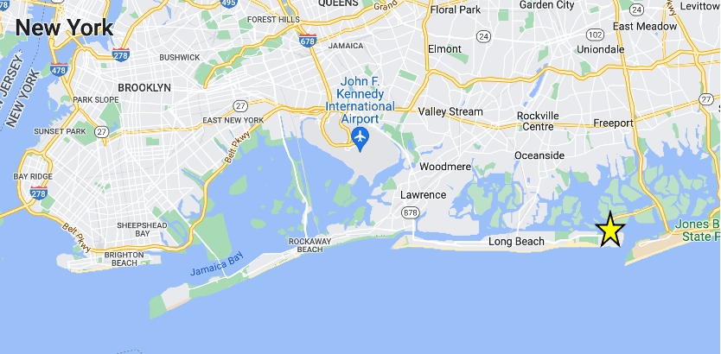

Figure 44. Map showing the location of the Reynolds Channel at Point Lookout NY USGS station with data from 2004 through present.

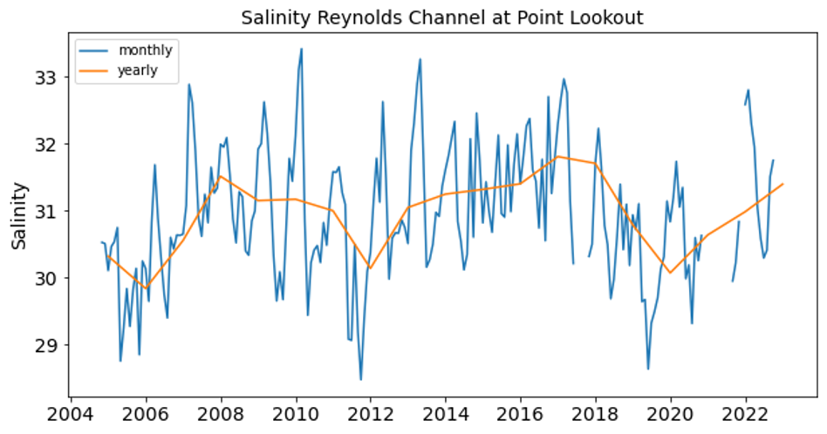

Figure 45. Monthly (blue) and yearly (orange) surface salinity at Reynolds Channel at Point Lookout NY.

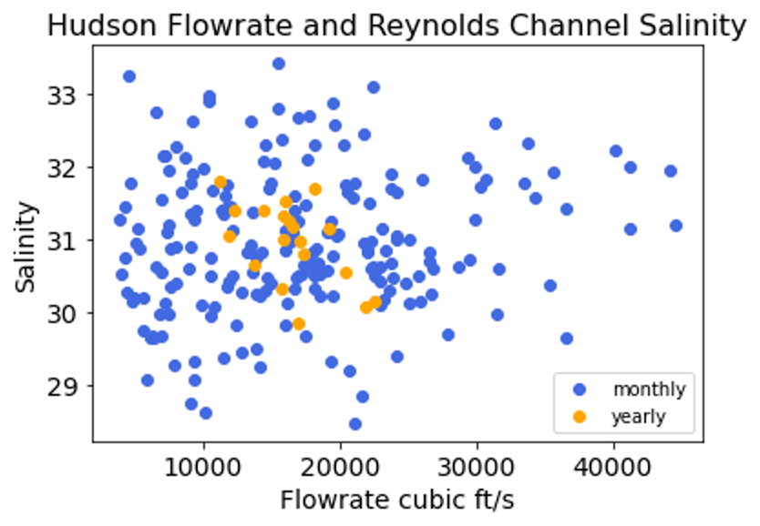

Figure 46. Monthly (blue) and yearly (orange) salinity values at Reynolds Channel at Point Lookout (y-axis) and Hudson flowrate at Green Island NY (x-axis). There is no apparent correlation between these two time series.

The observations from Reynolds Channel at Point Lookout NY are on the inshore portion of Long Island. Though they are influenced by the surface salinities on the seaward side of Long Island, they are also influenced by other processes including runoff from the local watershed. Although this USGS station provides the longest and highest resolution continuous surface salinity observational dataset within the NYB it is likely not the best data source for identifying Hudson River inputs into the NYB.

The GLORYS12 reanalysis (Lellouche, 2021) provides monthly mean surface salinity values from 1993 through 2020. This dataset is useful as the spatial resolution is relatively fine, 1/12 a degree, and it covers the whole NYB region. Surface salinity from this reanalysis in the region closest to the NY Harbor does not covary with the existing Hudson River flow indicator.

Moving forward, we will use the near surface salinity measurements from the Seawolf cruises and glider data to understand surface salinity changes since the beginning of our observational campaign. This will contribute to our development of the Hudson River flow indicator as well as the salinity indicator.

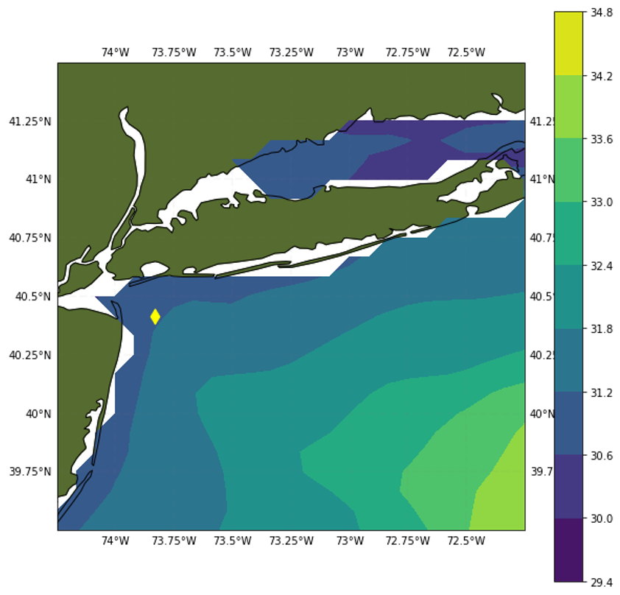

Figure 47. Mean surface salinity in the NYB region from GlORYS12 reanalysis (1993-2020). The yellow diamond indicates the grid point for surface salinity time series in subsequent figures.

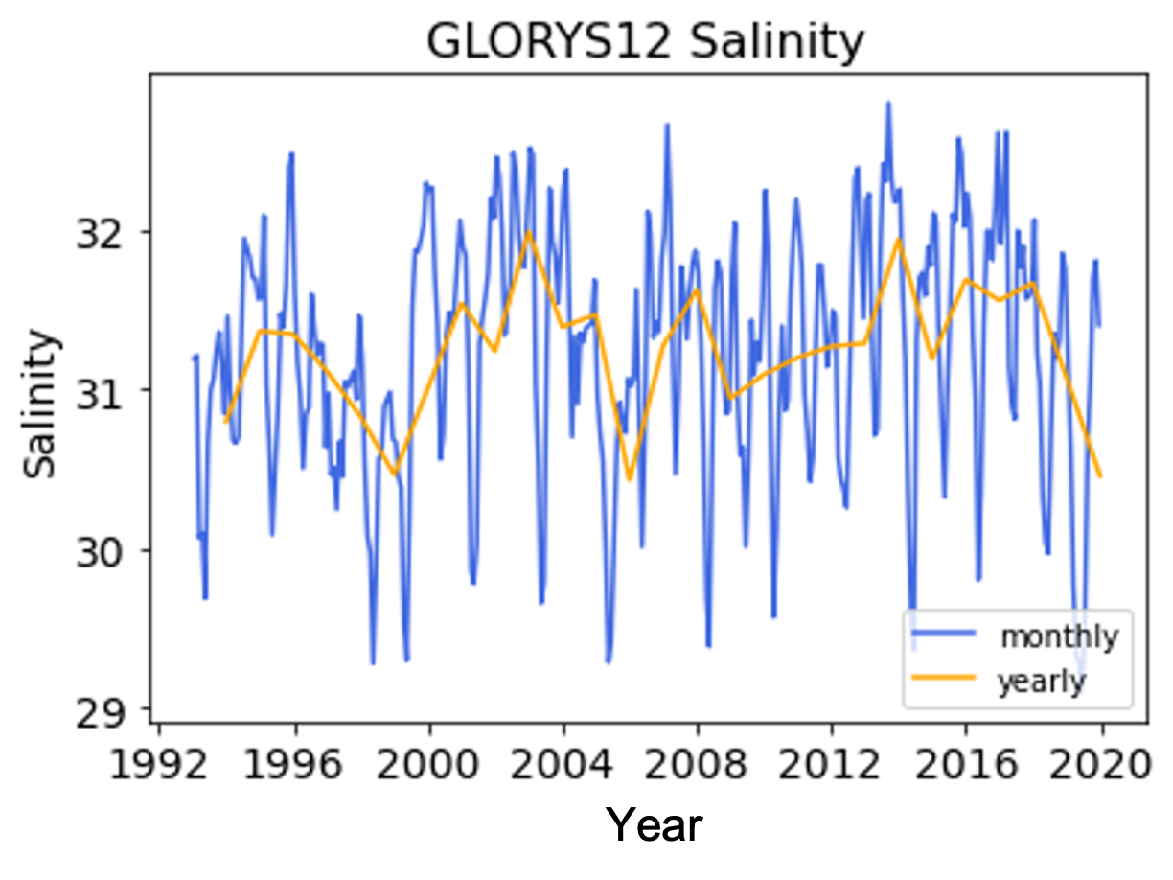

Figure 48. Surface salinity in the northwestern corner of the NYB near the entrance to the NY harbor from GLORYS12 reanalysis (Lellouche, 2021). Blue lines show monthly values and yellow lines show yearly values.

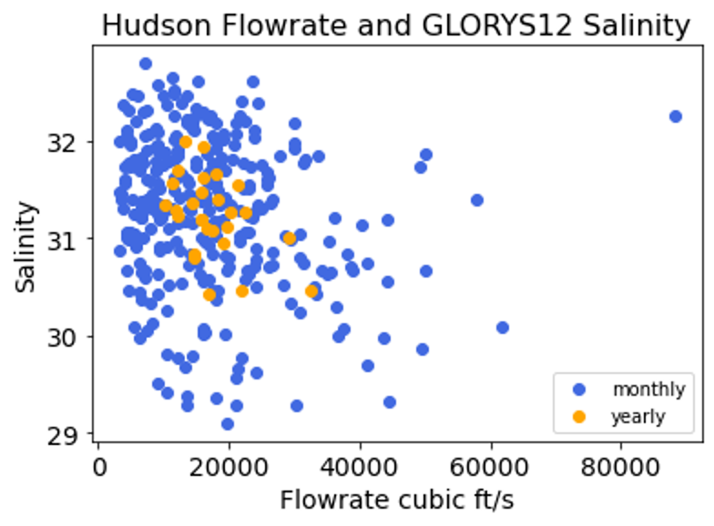

Figure 49. Monthly (blue) and yearly (orange) salinity values from GLORYS12 reanalysis (Lellouche, 2021; y-axis) and Hudson flowrate at Green Island NY (x-axis). There is no apparent correlation between these two time series.

# Data Sources

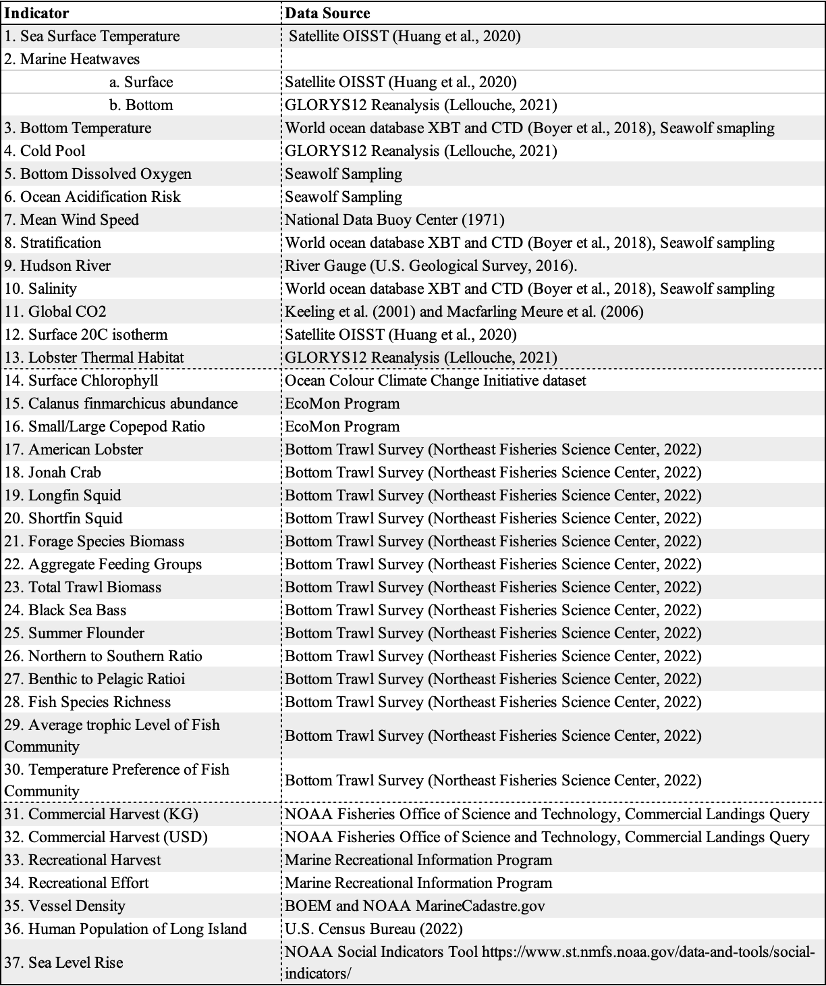

# 

# Acknowledgements

We would like to acknowledge the contributions of Kurt Heim, Brandon Beltz, and Jianqiong Zhan**.** This study has been conducted using E.U. Copernicus Marine Service Information; https://doi.org/10.48670/moi-00021.

# References

Bossart, G.D. (2011) Marine mammals as sentinel species for oceans and human health. *Veterinary Pathology* 48(3):676-690. doi:10.1177/0300985810388525.

Boyer, T.P., O.K. Baranova, C. Coleman, H.E. Garcia, A. Grodsky, R.A. Locarnini, A.V. Mishonov, C.R. Paver, J.R. Reagan, D. Seidov, I.V. Smolyar, K. Weathers, and M.M. Zweng. (2018) World Ocean Database 2018. A.V. Mishonov, Technical Ed., NOAA Atlas NESDIS 87. https://www.ncei.noaa.gov/sites/default/files/2020-04/wod_intro_0.pdf

Bradford A.L., D.W. Weller, A.E. Punt, Y.V. Ivashchenko, A.M. Burdin, G.R. VanBlaricom, R.L. Brownell Jr. (2012) Leaner leviathans: body condition variation in a critically endangered whale population. *Journal of Mammalogy* 93(1):251-266. https://doi.org/10.1644/11-MAMM-A-091.1

Bureau of Ocean Energy Management (BOEM) and National Oceanic and Atmospheric Administration (NOAA). MarineCadastre.gov.

Chant, R.J., J. Wilkin, W. Zhang, B.-J. Choi, E. Hunter, R. Castelao, S. Glenn, J. Jurisa, O. Schofield, R. Houghton, J. Kohut, T.K. Frazer, and M.A. Moline. (2008). Dispersal of the Hudson River plume in the New York Bight: Synthesis of observational and numerical studies during LaTTE. *Oceanography* 21(4):148–161. https://doi.org/10.5670/oceanog.2008.11.

Christiansen, F., S.M. Dawson, J.W. Durban, H. Fearnbach, C.A. Miller, L. Bejder, M. Uhart, M. Sironi, P. Corkeron, W. Rayment, E. Leunissen, E. Haria, R. Ward, H.A. Warick, I. Kerr, M.S. Lynn, H.M. Pettis, M.J. Moore. (2020) Population comparison of right whale body condition reveals poor state of the North Atlantic right whale. *Marine Ecology Progress Series* 640:1-16. https://doi.org/10.3354/meps13299

Ecosystem Monitoring program for the Northeast U.S. continental shelf. Archived by National Aeronautics and Space Administration, U.S. Government, OB.DAAC. https://doi.org/10.5067/SeaBASS/ECOMON/DATA001.

Governor Hochul Announces Distribution of $5.7 Million in Federal COVID-19 Relief to New York's Marine Fishing Industries (July 11, 2022) Governor Kathy Hochul. https://www.governor.ny.gov/news/governor-hochul-announces-distribution-57-million-federal-covid-19-relief-new-yorks-marine

Hazen, E.L., B. Abrahms, S. Brodie, G. Carroll, M.G. Jacox, M.S. Savoca, K.L. Scales, W.J. Sydeman, S.J. Bograd. (2019) Marine top predators as climate and ecosystem sentinels. *Frontiers in Ecology and the Environment* 17(10):565-574. https://doi.org/10.1002/fee.2125

Hirtle, N.O., J.E. Stepanuk, E.I. Heywood, F. Christiansen, L.H. Thorne. (2022) Integrating 3D models with morphometric measurements to improve volumetric estimates in marine mammals. *Methods in Ecology and Evolution* 13(11):2478-2490. https://doi.org/10.1111/2041-210X.13962

Huang, B., C. Liu, V. Banzon, E. Freeman, G. Graham, B. Hankins, T. Smith, and H.-M. Zhang. (2020) Improvements of the Daily Optimum Interpolation Sea Surface Temperature (DOISST) Version 2.1. *Journal of Climate* 34:2923-2939. doi: 10.1175/JCLI-D-20-0166.1

Keeling, C. D., S. C. Piper, R. B. Bacastow, M. Wahlen, T. P. Whorf, M. Heimann, and H. A. Meijer. (2001). Exchanges of atmospheric CO2 and 13CO2 with the terrestrial biosphere and oceans from 1978 to 2000. I. Global aspects, SIO Reference Series, No. 01-06, Scripps Institution of Oceanography, San Diego, 88 pages.

Lellouche, J.-M., E. Greiner, R. Bourdalle-Badie, G. Garric, A. Melet, M. Drevillon, C. Bricaud, M. Hamon, O. Le Galloudec, C. Regnier, T. Candela, C.-E. Testut, F. Gasparin, G. Ruggiero, M. Benkrian, Y. Drillet, and P.-Y. Le Traon. (2021) The Copernicus Global 1/12°Oceanic and Sea Ice GLORYS12 Reanalysis. *Frontiers in Earth Science* 9:698876. doi: 10.3389/feart.2021.698876

Lemos, L.S., A. Olsen, A. Smith, J.D. Burnett, T.E. Chandler, S. Larson, K.E. Hunt, L.G. Torres. (2021) Stressed and slim or relaxed and chubby? A simultaneous assessment of gray whale body condition and hormone variability. *Marine Mammal Science* 38(2);801-811. https://doi.org/10.1111/mms.12877

Macfarling Meure, C., D. Etheridge, C. Trudinger, P. Steele, R. Langenfelds, T. van Ommen, A. Smith, and J. Elkins. (2006) Law Dome CO2, CH4 and N2O ice core records extended to 2000 years BP. *Geophysical Research Letters* 33:L14810. doi:10.1029/2006GL026152.

Moore SE (2008) Marine mammals as ecosystem sentinels. *Journal of Mammalogy* 89(3):534-540. https://doi.org/10.1644/07-MAMM-S-312R1.1

NOAA Fisheries. (2021) Northeast Fisheries Impacts from COVID-19. Retrieved from (https://media.fisheries.noaa.gov/2021-02/Northeast-COVID-19-Impact-Snapshot-webready.pdf)

NOAA Fisheries Office of Science and Technology, Commercial Landings Query, Available at: www.fisheries.noaa.gov/foss, Accessed 08/30/2022.

Northeast Fisheries Science Center. (2022) Fall and Spring Bottom Trawl Surveys, https://www.fisheries.noaa.gov

Ocean Colour Climate Change Initiative dataset, Version 5.0, European Space Agency, available online at https://esa-oceancolour-cci.org.

Stepanuk, J.E., E.I. Heywood, J.F. Lopez, R.A. DiGiovanni Jr, and L.H. Thorne. (2021) Age-specific behavior and habitat use in humpback whales: implications for vessel strike. *Marine Ecology Progress Series* 663:209-222. https://doi.org/10.3354/meps13638

Thorne, L.H., E.I. Heywood, and N.O. Hirtle. (2022) Rapid restructuring of the odontocete community in an ocean warming hotspot. *Global Change Biology* 28(22):6524-6540. https://doi.org/10.1111/gcb.16382

US DOC/NOAA/NWS/NDBC > National Data Buoy Center (1971). Meteorological and oceanographic data collected from the National Data Buoy Center Coastal-Marine Automated Network (C-MAN) and moored (weather) buoys. [Stations 44065, 44025, and 44066]. NOAA National Data Buoy Center. Dataset. https://www.ndbc.noaa.gov/.

U.S. Census Bureau. (2022). Annual Population Estimates for New York State and Counties: Beginning 1970. https://data.ny.gov/Government-Finance/Annual-Population-Estimates-for-New-York-State-and/krt9-ym2k

U.S. Geological Survey. (2016). National Water Information System data available on the World Wide Web (USGS Water Data for the Nation), https://waterdata.usgs.gov/ny/nwis/rt.